Smart Inventory

Software Requirements Specification

1.0

05-02-2024

Sangeetha Baddam  
Jonah Nishanth Bathini  
Chandana Annadi  
Jayanth Anumula

Submitted in partial fulfilment

Of the requirements of

CSIS 44-691 Graduate Directed Project 1

# Revision History

|  |  |  |  |
| --- | --- | --- | --- |
| **Date** | **Description** | **Author** | **Comments** |
| 05/02/2024 | Version 1 | All Team Members | Initial documentation |
| 05/07/2024 | Version 2 | All Team Members | Updated Documentation |
| 05/16/2024 | Version 2 | All Team Members | Added data flow diagram and sequence diagram |
|  |  |  |  |

# Document Approval

The following Software Requirements Specification has been accepted and approved by the following:

|  |  |  |  |
| --- | --- | --- | --- |
| **Signature** | **Printed Name** | **Title** | **Date** |
|  |  |  |  |
|  |  |  |  |
|  |  |  |  |

**Table of Contents**

**Table of Contents Page Number**

1. Introduction

1.1 Purpose

1.2 Scope

1.3 Definitions, Acronyms, and Abbreviations

1.4 References

1.5 Overview

1. Specific Requirements

2.1 Product Perspective

2.2 Product Functions

2.3 User Characteristics

2.4 General Constraints

2.5 Assumptions and Dependencies

3. Specific Requirements

3.1 External Interface Requirements

3.1.1. User Interfaces

3.1.2. Hardware Interfaces

3.1.3. Software Interfaces

3.1.4. Communications Interface

3.2 Functional Requirements

3.3 Use Cases

3.4 Class/Objects

3.5 Non-Functional Requirements

3.5.1. Performance

3.5.2. Reliability

* + 1. Availability
    2. Security
    3. Portability
  1. Inverse Requirements
  2. Design Constraints
  3. Logical Database Requirements
  4. Other Requirements
  5. Prototypes (for complete project)
  6. Use Case Diagrams

1. Design

4.1. ER diagram

4.2. GUI

1. Analysis Models

4.1. Data Flow Diagram

4.2. Sequence Diagram

## Introduction

**Purpose:**

The purpose of the Smart Inventory Project is to create an innovative warehousing solution that takes advantage of innovative technology to provide users with a seamless and efficient platform for managing their inventory. By offering a digital interface for both warehouse operators and users, the project aims to automate inventory tracking. Through this system, users can store their products in the warehouse, with transparent pricing and billing processes, thereby enabling them to focus on their core business activities while ensuring the safety and accessibility of their inventory.

**Scope:**   
   
The smart inventory system aims to streamline the process of storing and managing products within a warehouse facility. It facilitates users in securely storing their products, receiving accurate pricing estimates, and tracking the status of outgoing shipments from warehouse. The system enables users to submit requests to send products out of warehouse, make bill payments monthly, and track the shipped products through a user-friendly interface. It can efficiently manage outgoing shipments and maintain an accurate inventory database. It does not include physical warehouse operations such as Efficient shipping, Optimized Warehouse Operations and Automated Billing Process.

**Definitions Acronyms, and Abbreviations:**

**Inventory Management:** The process of efficiently overseeing the flow of goods into and out of an organization's inventory, including products in inventory, orders confirmation, tracking shipments and order history.

* **Web Application:** A computer program or software application accessed and used through a web browser, typically residing on a remote server and delivering content and functionality to users over the internet.
* **Content Management System (CMS):** A software application or platform that allows users to create, manage, and modify content, such as text, images, and documents, on a website or web application.
* **CRUD:** An acronym for Create, Read, Update, Delete, which represents the four basic operations performed on data in a database system.
* **API (Application Programming Interface):** A set of rules, protocols, and tools that allows different software applications to communicate and interact with each other, enabling data exchange and functionality integration.
* **UI (User Interface):** The visual elements and interactive components of a software application or website through which users interact and engage with the website.
* **UX (User Experience):** The overall experience and satisfaction a user derives from interacting with a product, system, or service, encompassing aspects such as usability, accessibility, and emotional response.
* **HTML (Hypertext Markup Language)**: The standard markup language for creating web pages and web applications.
* **CSS (Cascading Style Sheets)**: A style sheet language used for describing the presentation of a document written in HTML.
* **JS (JavaScript)**: A programming language that enables interactive web pages and is essential for web development.
* **DB (Database**): used to store data on remote servers for persistence. They provide a structured and efficient way to organize, retrieve, and manage large amounts of data.
* **HTTP (Hypertext Transfer Protocol)**: The protocol used for transmitting data over the World Wide Web.
* **HTTPS (Hypertext Transfer Protocol Secure):** An extension of HTTP used for secure communication over a computer network, especially the internet.
* **SQL (Structured Query Language)**: A domain-specific language used in programming and designed for managing data held in a relational database management system.
* **MVC (Model-View-Controller)**: A software architectural pattern for implementing user interfaces. It divides a given software application into three interconnected components: the model, the view, and the controller.
* **SPA (Single Page Application)**: A web application that interacts with the user by dynamically rewriting the current page rather than loading entire new pages from a server.
* **REST (Representational State Transfer)**: A software architectural style that defines a set of constraints to be used for creating web services.
* **JSON (JavaScript Object Notation)**: A lightweight data-interchange format that is easy for humans to read and write and easy for machines to parse and generate.
* **AJAX (Asynchronous JavaScript and XML)**: A set of web development techniques using many web technologies on the client side to create asynchronous web applications.
* **URL (Uniform Resource Locator)**: A reference to a web resource that specifies its location on a computer network and a mechanism for retrieving it.

**1.4 References**

* Mozilla Developer Network (MDN) for HTML, CSS, and JavaScript documentation
* Angular.io or React.js documentation for building SPAs using popular JavaScript frameworks
* JSON.org for the official JSON specification and documentation.

**1.5. Overview**

The Smart Inventory project aims to develop a web application that efficiently manages inventory for businesses, integrating modern technologies. The system will utilize APIs for seamless integration, provide a user-friendly CMS for content management, and ensure data security through HTTPS protocols. The project will follow a CRUD approach for managing inventory items and incorporate UI/UX best practices to enhance user satisfaction. Web application will be leveraged for hosting and scalability, with continuous QA to ensure the system's reliability and performance.

**General Description**

**2.1. Product Perspective:**

The Smart Inventory web application serves as a comprehensive solution for businesses to manage their inventory efficiently. It is designed to integrate seamlessly providing a unified platform for inventory management. The users and warehouse managers can interact to raise a request to send products, track shipped packages to warehouse in real-time. It also incorporates a user-friendly CMS for content management and customization, allowing businesses to tailor the application to their specific needs.

**2.2. Product Functions:**   
   
 **User Registration and Authentication:**

* Users can register accounts on the platform.
* Authentication mechanisms ensure secure access to the system

**Product Listing and requests:**

* There will be a listing page which will be accessed by warehouse manager which has list of products that are in Inventory
* User can raise a request to warehouse send the products from warehouse

**Bill payment and Pricing:**

* Users get the bill monthly basis based on the time of products in warehouse.

**Inventory Management:**

* The system maintains a comprehensive inventory database.
* It tracks product quantity and location in real-time.
* Inventory are updated as products are stored, retrieved, or shipped out.

**User Management:**

* Provides role-based access control to ensure security and privacy.

**Order History and Tracking:**

* Users access their order history, including past requests, invoices, and payment records.
* They track the status of outgoing shipments using unique tracking numbers provided by the system.

**Communication and Notifications:**

* Automated notifications are sent to users including request confirmation, payment reminders, shipment tracking updates, and delivery notifications.

**Content Management:**

* Offers a user-friendly CMS for managing website content, including text, images, videos, and documents.

**2.3. User Characteristics:**

Warehouse managers will confirm the shipment and provide the price of shipment and managers can view all the products in the inventory.  
Users can create a shipment and request the warehouse for shipment confirmation. Once shipment is confirmed user can pay the price of shipment after payment the shipment can be tracked using tracking number generated after the payment.

**2.4. General Constraints:**

* Constraints may exist regarding the choice of programming languages, frameworks, and libraries based on project requirements and organizational standards
* Operational constraints include the need for regular maintenance, updates, and support to ensure the system's ongoing functionality and performance
* Constraints may exist regarding the availability and scalability of infrastructure resources, such as servers, networks
* The system must adhere to accessibility standards to accommodate users with disabilities and ensure inclusive access to all features and functionalities

**2.5. Assumptions and Dependencies:**

* It is assumed that the data entered the system by users, such as product information and inventory updates, will be accurate and up to date.
* The system may depend on third-party APIs for functionalities such as payment processing, shipping tracking, or other external services.
* Dependencies may exist on specific development tools, frameworks, or libraries used for building the Smart Inventory web application.
* The system may depend on a specific database management system (e.g., MySQL, PostgreSQL) for storing and managing inventory data.
* The availability and reliability of the hosting service used to deploy the Smart Inventory system are critical dependencies for ensuring continuous uptime and performance.

**Specific Requirements**

**3.1 External Interface Requirements:**

User dashboard provides users with an overview of their shipment status, notifications and order history.

User Request form where users can submit requests for sending products in the warehouse. It includes fields for product details, quantity, and shipping label.

Payment dashboard where users can view invoices, make payments, and track billing history.

Order Tracking dashboard allows users to track the status of their outgoing shipments using unique tracking numbers.

#### **3.1.2 Hardware Interfaces**

The Smart Inventory system should be accessible through standard web browsers such as Google Chrome, Mozilla Firefox, and Safari.

Users require an active internet connection to access the web application and interact with its features.

#### **3.1.3 Software Interfaces**

Utilize Node.js frameworks like Express.js to handle database interactions.

Use Sequelize libraries for easy integration with relational databases such as MySQL or PostgreSQL.

Implement CRUD operations (Create, Read, Update, Delete) for managing inventory data in the database.

Use React for building the user interface components of the CMS.

Implement features for creating, editing, and managing website content using React components.

Utilize libraries like React-Router for navigation of website.

Utilize Node.js middleware such as Express.js to handle payment gateway integration.

#### **3.1.4 Communications Interface**

Enables users to communicate with warehouse managers directly through the web application for inquiries or support requests.

Notifications are sent to users for various events, such as request confirmation, shipment tracking updates, and delivery notifications.

**3.2 Functional Requirements**

**User Registration and Authentication**:

* Users should be able to register for an account within the system.
* During registration, users must provide necessary information such as username, email address, and password.
* The system should validate user input to ensure data integrity and security.
* Upon successful registration, users should receive a confirmation email or notification.
* Authentication mechanisms should be in place to verify user identity during login, utilizing secure authentication protocols such as OAuth or JWT.
* Passwords should be securely hashed and stored to protect user credentials.

**Product Listing and Requests**:

* Warehouse managers should access a comprehensive list of available products in the inventory.
* The system should provide a user-friendly interface for users to submit requests.
* Request forms should include fields for specifying product details, quantity and shipping label that user wants to ship out from the warehouse.
* Users should receive confirmation notifications upon successful approval of request.

**Billing and Payment**:

* Users should receive monthly bills detailing warehouse fees, including itemized costs.
* The system should integrate with secure payment gateways to facilitate billing transactions.

**Inventory Management**:

* The system must maintain an accurate and up-to-date inventory database.
* Inventory records should include details such as product name, description, quantity on hand and any associated metadata.
* The system should support real-time inventory tracking, with automatic updates as products are stored, or shipped out.
* Warehouse managers should be able to generate reports.

**Order History and Tracking**:

* Users should have access to a comprehensive display of past requests, and payment records.
* Each user request will have a unique tracking number, allowing users to track the status of outgoing shipments.
* The system should provide real-time updates on the progress of requests, including notifications for key milestones (e.g., product packed, product shipped, out for delivery).

**Communication and Notifications**:

* The system should support automated notifications to keep users informed of important events and updates.
* Notifications should be sent in-app messages, depending on user preferences.
* Examples of notifications include request confirmation, payment reminders, shipment tracking updates, and delivery notifications.
* Users should be able to communicate with warehouse managers directly through the system.

**CMS Interface**:

* Develop a user-friendly CMS interface using React or Angular components to manage website content.
* Implement version control functionality to track changes made to content over time, enabling users to revert to previous versions if needed.

**Backend (Node.js)**:

* Develop RESTful API endpoints using Node.js and Express.js to handle CRUD operations for managing Smart Inventory.
* Integrate with a relational database or non-relational database (e.g., MySQL, PostgreSQL,MongoDB) to store content data, utilizing ORMs or mongoose for database interactions.
* Implement user authentication and authorization mechanisms using libraries like Passport.js to ensure that only authorized users can access CMS functionalities.
* Validate and sanitize user input to prevent security vulnerabilities such as SQL injection or cross-site scripting (XSS) attacks.

**3.3 Use Cases of Smart Inventory:**

* User registers for an account on the Smart Inventory system by providing necessary details such as username, email, and password.
* Users will send products to the warehouse and those products will be stored in the warehouse.
* Based on the users request and entered information such as product name, quantity and shipping label
* The warehouse manager reviews the request and approves the request and then packs the product based on user request and ships out the products from the warehouse.
* The user receives a warehouse bill monthly and proceeds to make payment securely through the integrated payment gateway.
* Users track the status of their outgoing shipments using unique tracking numbers provided by the system, receiving real-time updates on shipment progress.
* User communicates with warehouse managers or customer support representatives directly through the system, submitting inquiries or support requests and receiving timely responses.

**3.4 Classes:**

In the context of the Smart Inventory system, here are some potential classes or objects:

* User class represents individuals using the system, with attributes such as username, email, and password. A user registers for an account, submits requests, tracks shipments, and communicates with support.
* Product class represents items stored in the inventory, with attributes including name, description, quantity.
* The Request class represents requests from users to send products from the warehouse, with attributes like product details, quantity, and shipping label. users submit requests, which warehouse managers then approve or reject.
* Billing class represents billing information for warehouse fees, with attributes such as user, fee amount, and payment status.
* Packaging class represents the packaging process for products stored in the warehouse.
* Shipment class represents outgoing shipments of stored products, with attributes like tracking number, status, and delivery date.
* Admin class approve requests and oversee system operations.
* Communication class represents messages exchanged between users and support staff, with attributes like sender, recipient, and message content.

**3.5 Non- Functional Requirements:**

**Performance:** The system should provide quick response times and efficient data processing to ensure a smooth user experience, especially during peak usage times. Users expect the system to load swiftly, process requests promptly, and display inventory information without delays.

**Reliability:** Users rely on the system to consistently and accurately handle requests, maintain inventory records, and manage billing transactions without unexpected interruptions or errors. The system should be dependable and resilient, ensuring consistent availability and functionality under normal and abnormal conditions.

#### **Availability:** The system should be available to users with minimal downtime or maintenance windows. Users require uninterrupted access to submit requests, track shipments, and manage inventory, regardless of the time of day or the user's location**.**

#### **Security:** Users trust the system to safeguard their personal information, financial data, and confidential inventory records from unauthorized access or breaches. The system should prioritize data security and privacy, implementing robust measures to protect user information and ensure secure payment transactions.

#### **Portability:** The system should be easily deployable and adaptable to different environments or infrastructures, supporting scalability and flexibility. Administrators should have the flexibility to deploy the system on various hosting platforms or integrate it with existing infrastructure without significant modifications or disruptions.

**3.6 Inverse Requirements**

* **Poor Performance:** The system experiences slow response times, delays in processing requests, and sluggish performance during peak usage times, leading to frustration among users.
* **Unreliability**: The system exhibits unexpected interruptions, errors, or inconsistencies in handling requests, managing inventory records, or processing billing transactions, eroding user trust and confidence.
* **Downtime**: The system experiences frequent and prolonged periods of unavailability, preventing users from accessing critical functionalities such as submitting requests, tracking shipments, or managing inventory, resulting in disruptions to business operations.
* **Security Breaches**: The system fails to adequately protect user information, financial data, or confidential inventory records, resulting in unauthorized access, data breaches, or compromises of sensitive information, leading to legal and reputational consequences.
* **Inflexibility**: The system lacks adaptability and portability, making it challenging for administrators to deploy or integrate it with different environments or infrastructures, hindering scalability and limiting options for system expansion or optimization.

**3.7 Design Constraints:**

* Use frameworks for frontend and backend so that we can reduce design constraints and increase performance, scalability and make website responsive.
* The system should be designed to handle a large volume of requests, inventory updates, and shipping transactions to accommodate increasing traffic and data.
* The system should ensure the confidentiality, integrity, and availability of user and warehouse data. This includes secure communication channels, access controls, and data encryption
* The system should be user-friendly and easy to use for both warehouse managers and users.
* The system should always be reliable and available, with minimal downtime for maintenance or upgrades.
* The system should be easy to maintain and update, with clear documentation and modular code.

**3.8 Logical Database Requirements:**

**Entities:**

* User: Stores information about the users, including their roles (warehouse manager or user).
* Product: Stores information about the products, including their details.
* Request: Stores information about the requests raised by users, including product details, quantity, and shipping label.
* Inventory: Stores information about each product in the inventory.
* Packaging: Represents the packaging process of the product.
* Bills: This table stores information about the bills generated for users on a monthly basis. Each bill includes the user ID to whom it is issued and the total amount to be paid for the for that month.
* Shipping: Stores information about the shipping process, including the request ID, shipping date, and TrackingNumber.

**Relationships :**

**User - Request:** A user can raise multiple requests, but each request is raised by only one user it is One-to-Many relationship.

**Product - Request**: Multiple products can be associated with multiple requests, and vice versa it is Many-to-Many relationship".

**User - Bill:** For each user one bill will be generated on monthly basis

**Packaging - Shipping**: A packed product is shipped out of the warehouse it is One-to-One relationship.

**Shipping- Inventory:** A shipped product decreases the quantity of the product in the inventory it is One-to-One relationship.

**Fields:**

* Users: _id, username, password, role
* Products: _id, product name, upsc number , ArrivalTime, Delivery Time
* Requests: _id, userId, product name and quantity, shippingLabel,tracking number.
* Bills: _id, productId, Time Totalamount
* Inventory: _id, productname, quantity
* Packaging: _id, requestId, packagingDate, packagingTime   
  Shipping: _id, requestId, shippingDate, deliverydate,tracking number,productId’s and status

**Flow of Application:**

* User sends one or more products to the warehouse.
* After that user raises a request about which product must be shipped out of the warehouse by entering product name, qty and shipping label.
* The request will be approved by the warehouse manager and based on shipping label product will be shipped out of the warehouse by packing the product.
* The warehouse bill will be generated monthly based on product time in warehouse and will be paid by the user.
* After packing, the product is shipped out of the warehouse and sent to the customer, and the inventory quantity is decreased.
* Using tracking number status of the shipment can be tracked.

**3.9 Other Requirements:**

**Packaging Management:**

* Log packaging details including request ID, packaging date, and time.
* Manage the packaging process before shipping.

**Shipping Management:**

* Track shipping details like request ID, shipping date, status of shipment.
* Update inventory upon shipping to decrease product quantity**.**

Ensure that the website is responsive and optimized for various devices and screen sizes, including desktops, laptops, tablets, and smartphones.

Use HTTPS protocol for secure communication and encrypt sensitive data such as passwords and payment information.

Provide comprehensive documentation for developers, administrators, and end-users, including system architecture, API documentation, user guides, and troubleshooting resources.

Offer training sessions or tutorials to educate users on how to use the system effectively and efficiently.

Unit Testing and Integration Testing should be performed at every point when we add new functionality to the code.

**3.10 Prototypes:**

**Log In and Sign In:**

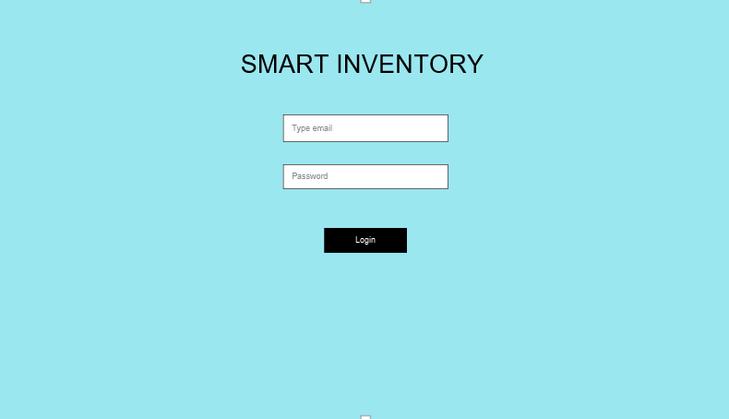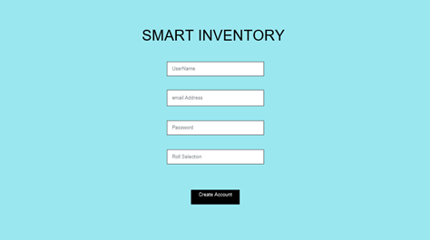

Using Register and login pages accounts can be created, and others can login to the website.

**Enquiry:**

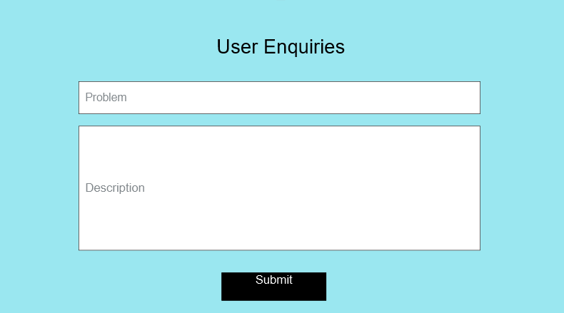

Users can submit requests about queries and the warehouse manager will resolve the queries.

**User Request**

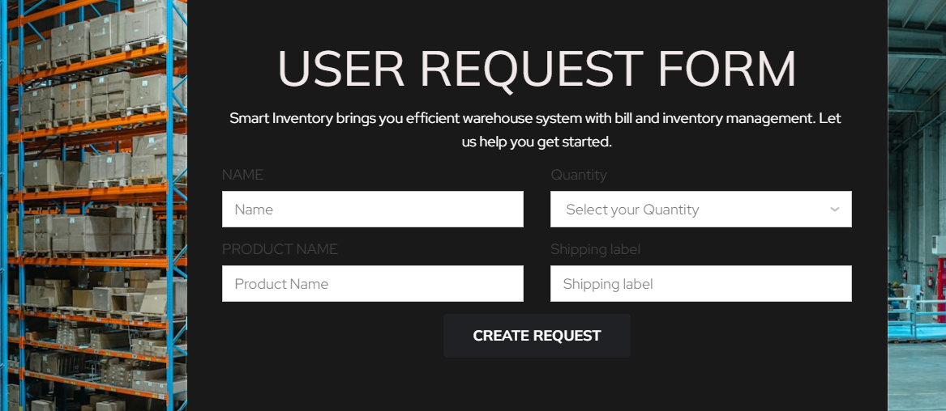

Users can raise a request by entering the above details in the form that needs to be shipped.

**Add products to database by Warehouse Manager:**

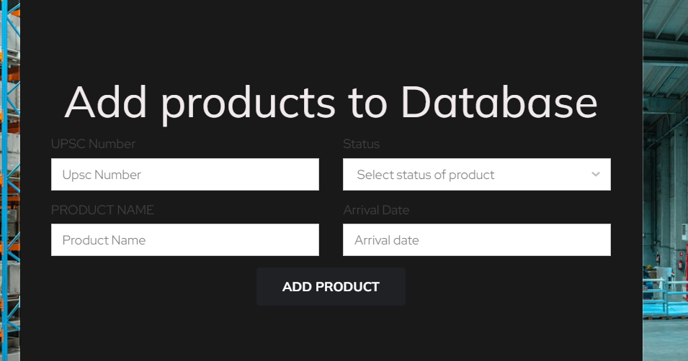

Adds products to database after checking the products sent by user.

**Order History:**

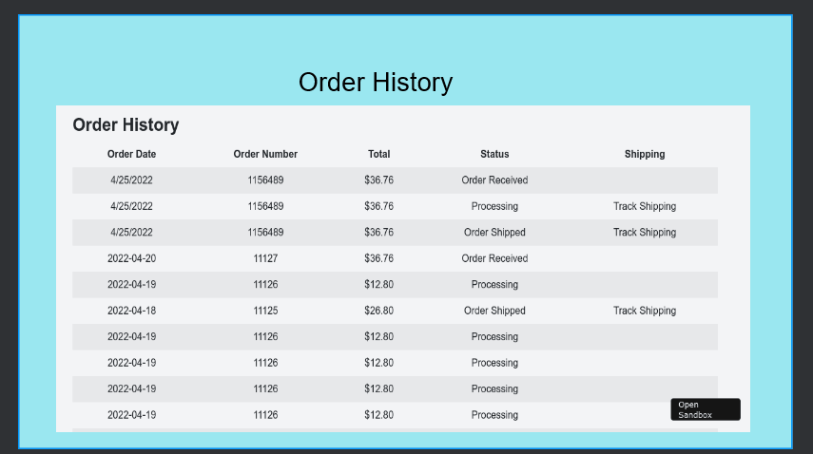

Users can view the order's history and see the status of the orders.

**Product listing prototype :**  
  
Product Listing Page  
 |  
Display Products with Details  
 |  
Filter/Search Products Inventory

Warehouse manager can view the products in the inventory that has the product details

**Order Tracking prototype:**

Order Tracking search box  
 |  
 Display Order History, Shipment Tracking Details, Status Updates  
 |  
 Track Shipments ----View Detailed Order Information

Users can track the shipment status using the tracking number generated after bill payment.

**3.11 Use Case Diagrams**

**User Use cases**

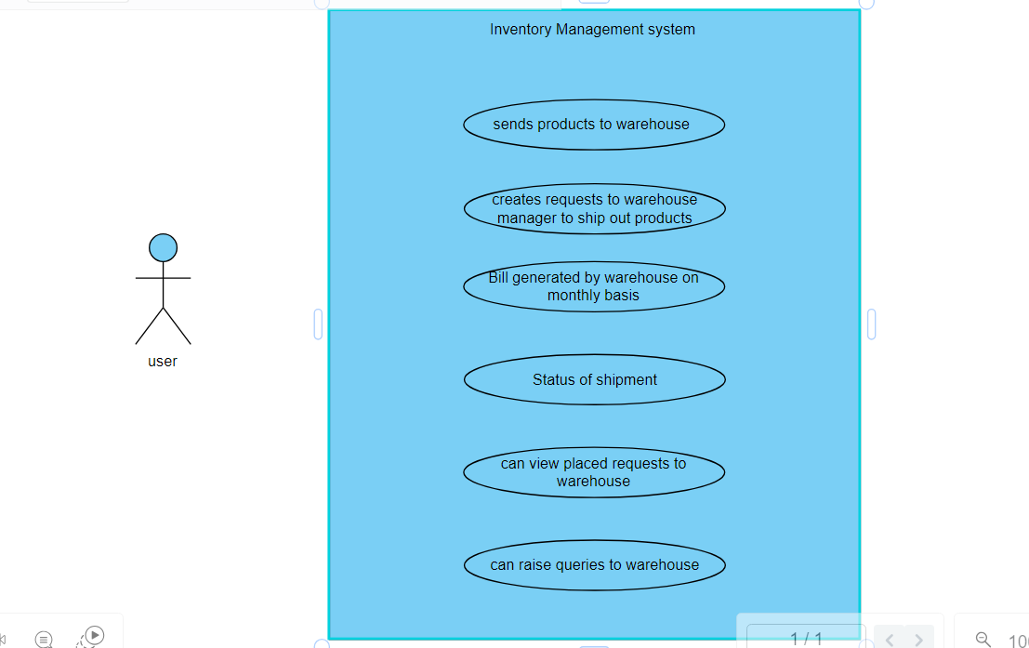

* A user wants to access the Smart Inventory system. They register for an account and authenticate themselves to gain access.
* User will send products to warehouse
* Users can raise request to warehouse to ship out the products based on shipping label and product details entered in request.
* Users can track the shipment and view the request history.
* User can raise a query for warehouse manager about problems.

**Warehouse manager**

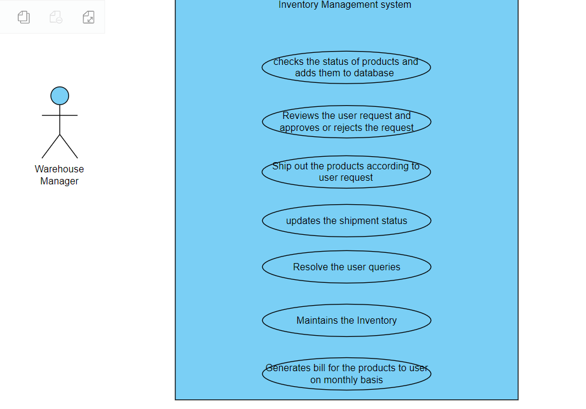

* Warehouse manager checks the products sent by user and adds them to database
* Warehouse Manager should generate the bill monthly basis to user
* Warehouse Manager can resolve the queries of users
* The warehouse manager needs to manage the inventory of products stored in the warehouse.
* Warehouse manager ship out the products based on user request
* The warehouse manager needs to manage the packaging and shipping of products stored in the warehouse.

**4. Design**

**ER Diagram :**

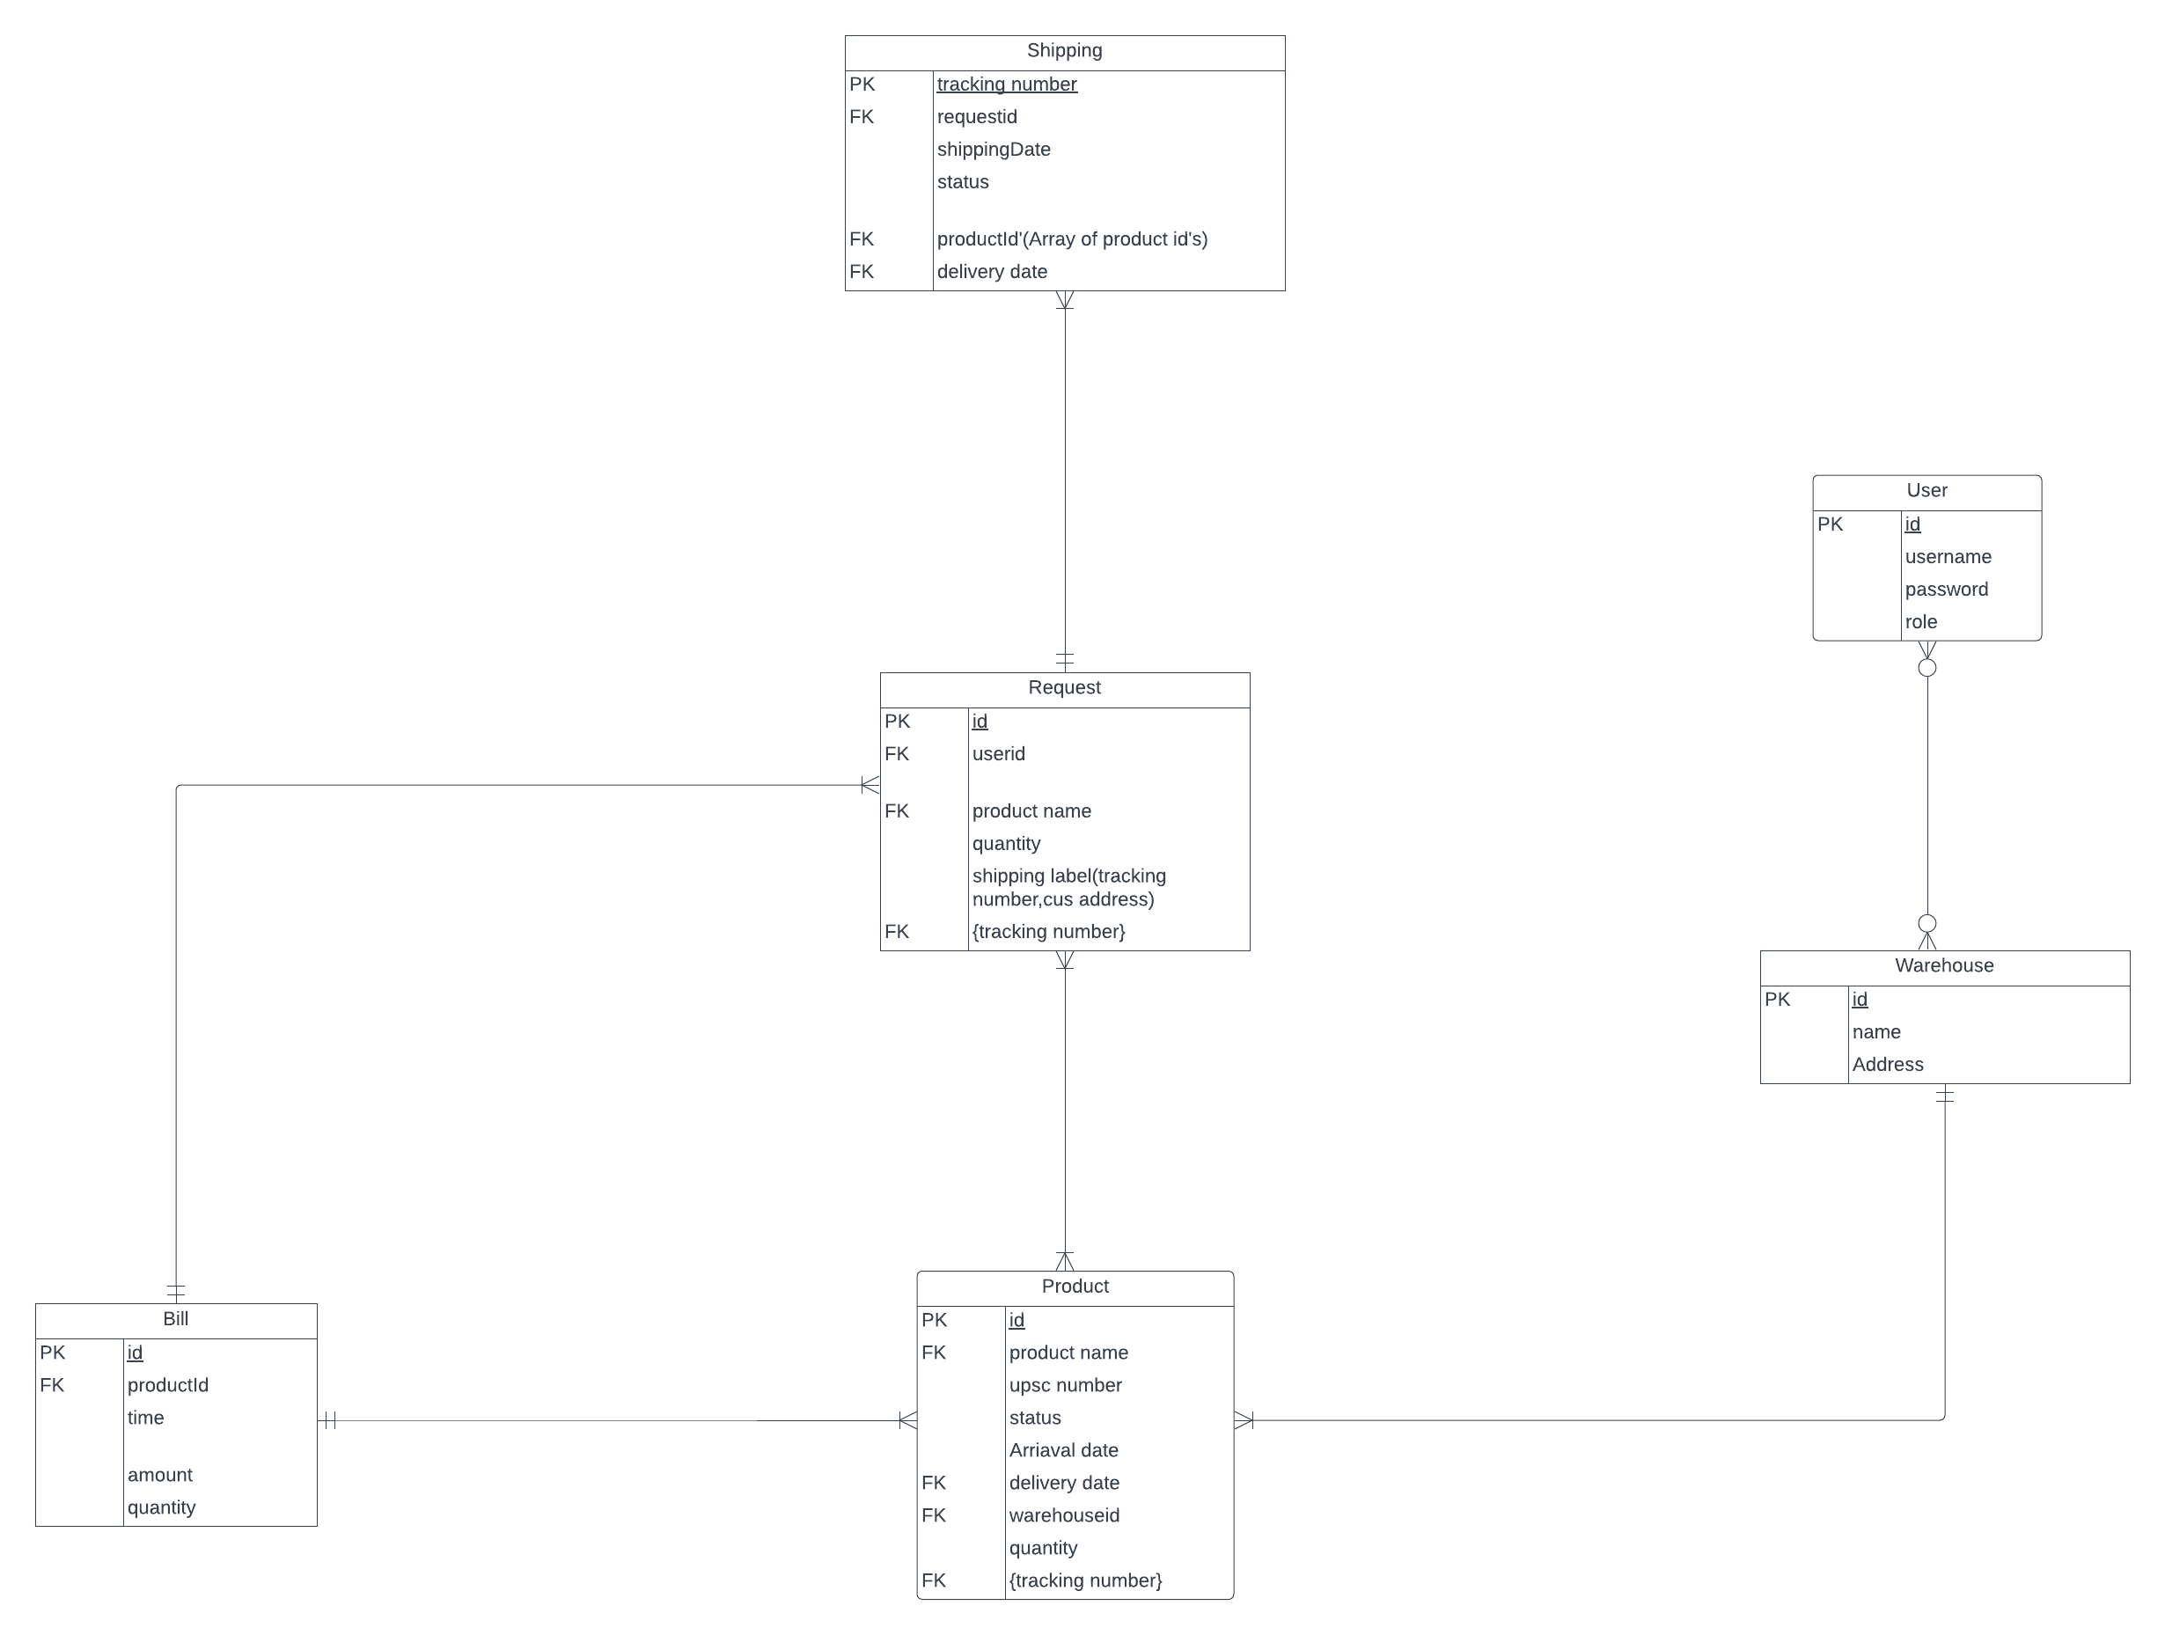

#### 

**4.2. GUI**

**Log In :**

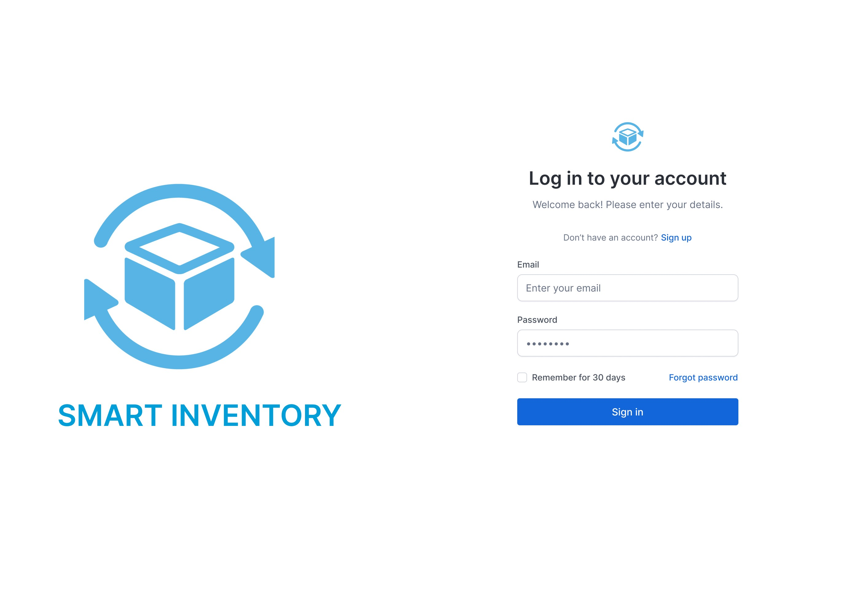

**Sign In :**

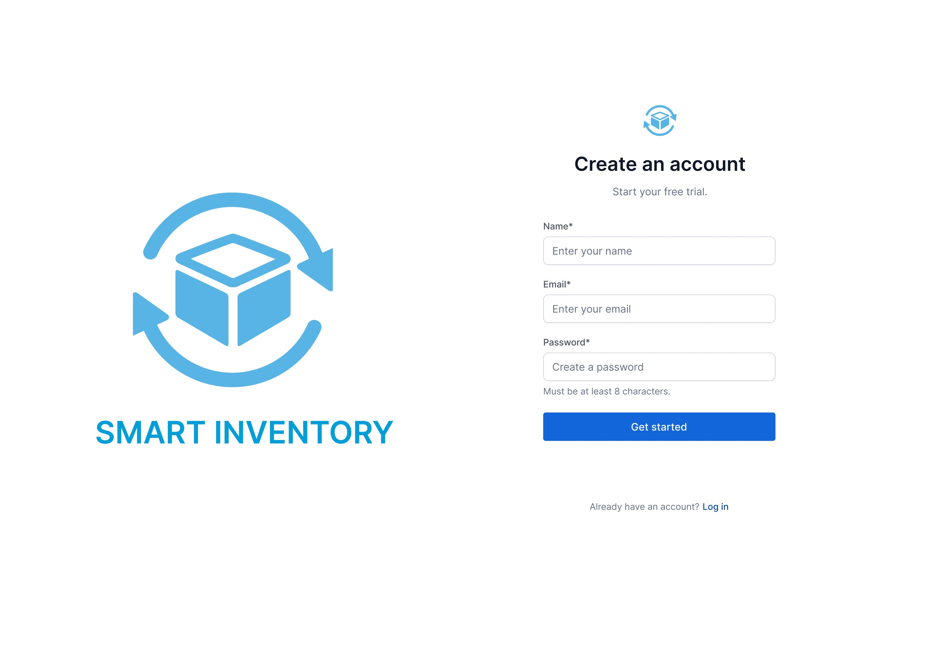

Inventory Dashboard :

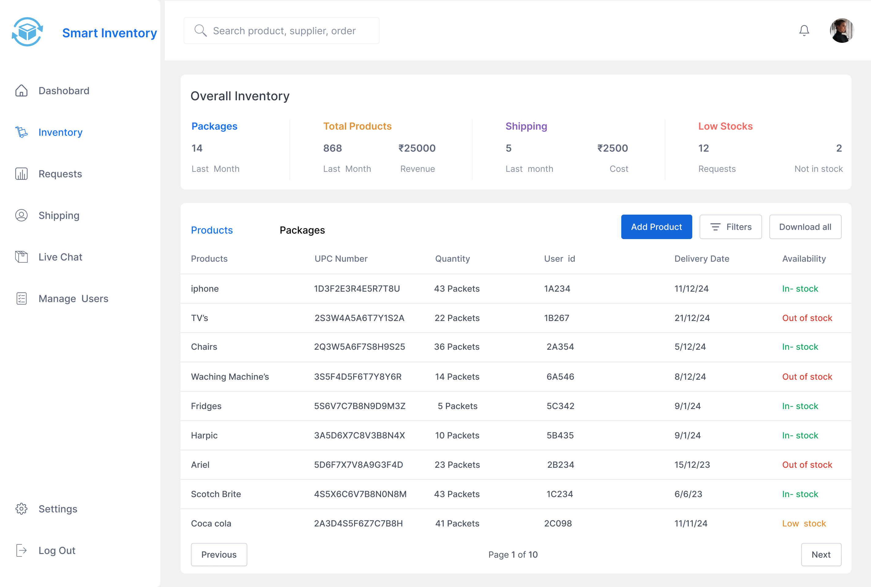

Add Product :

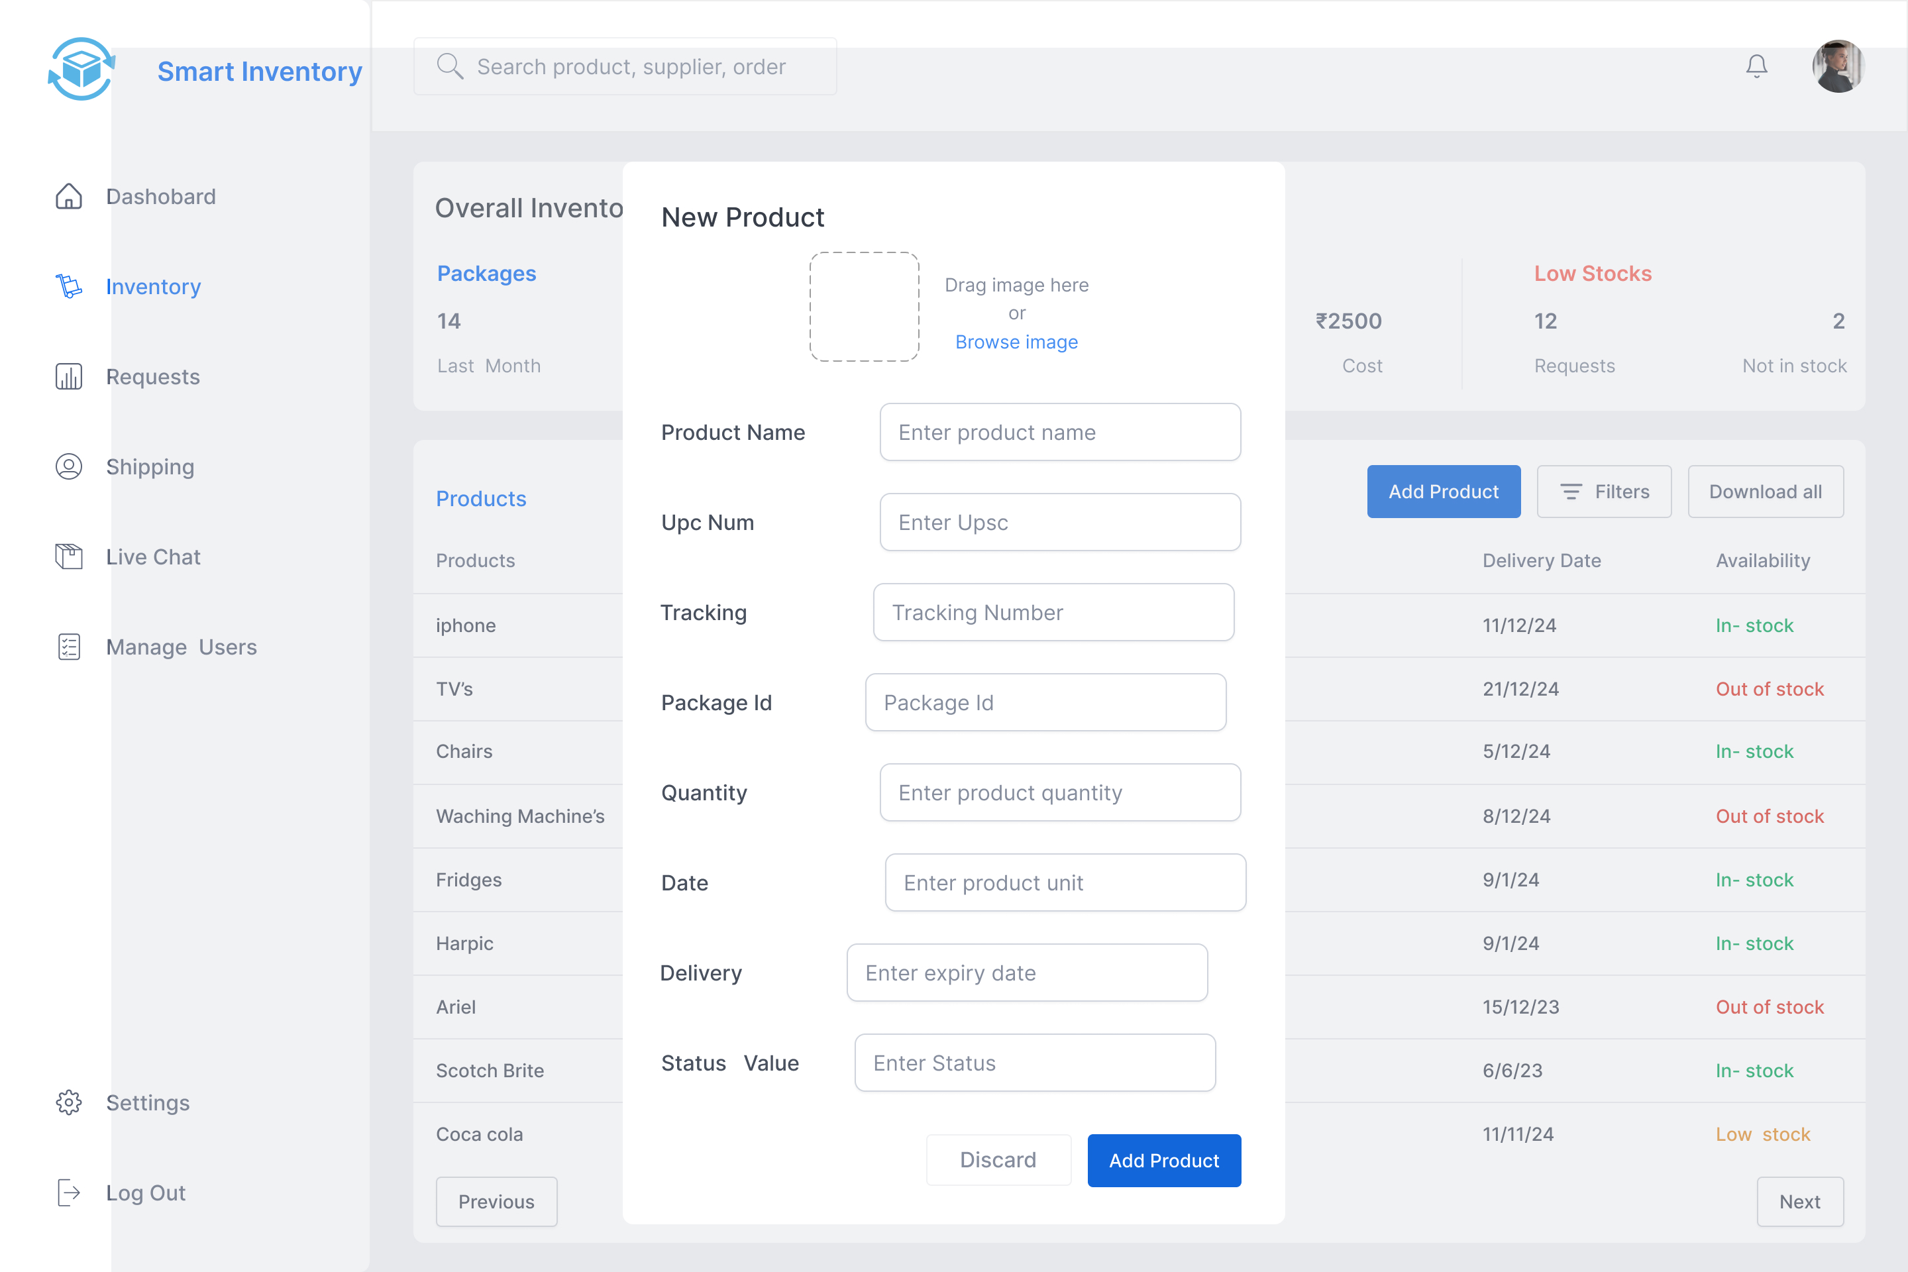

Shipping :

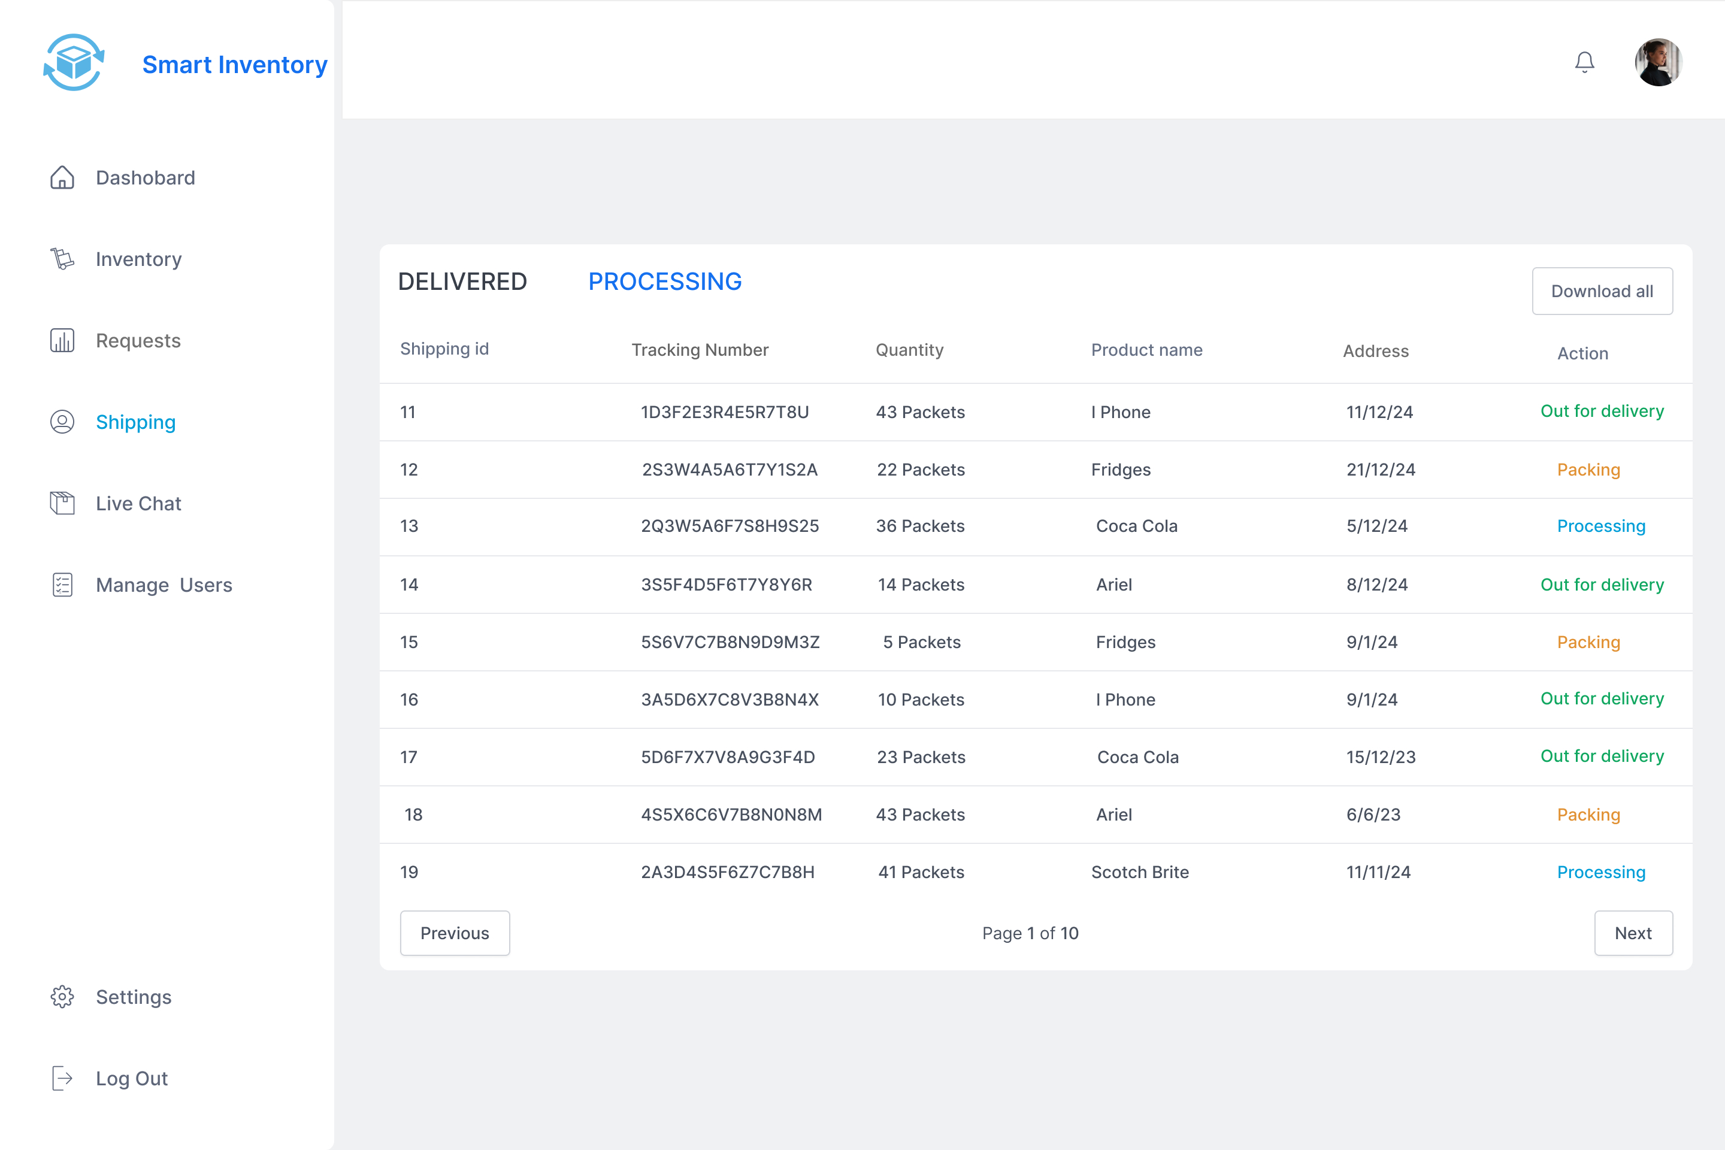

Request History :

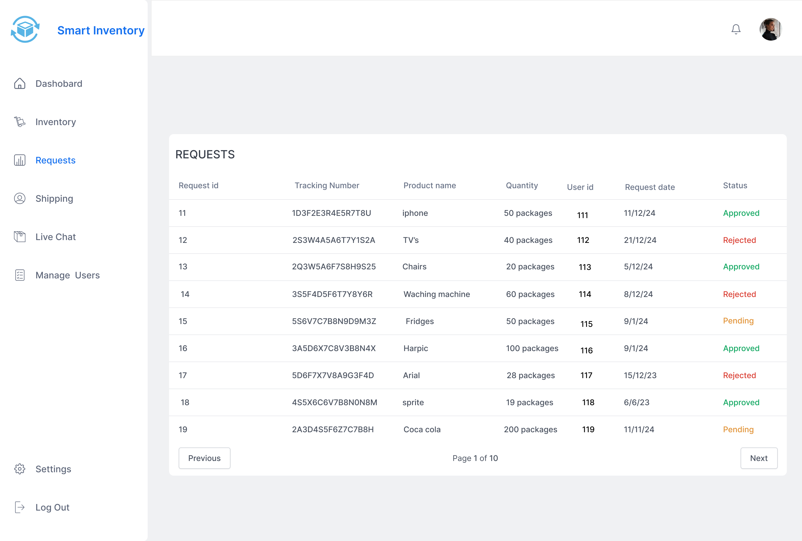

Product History :

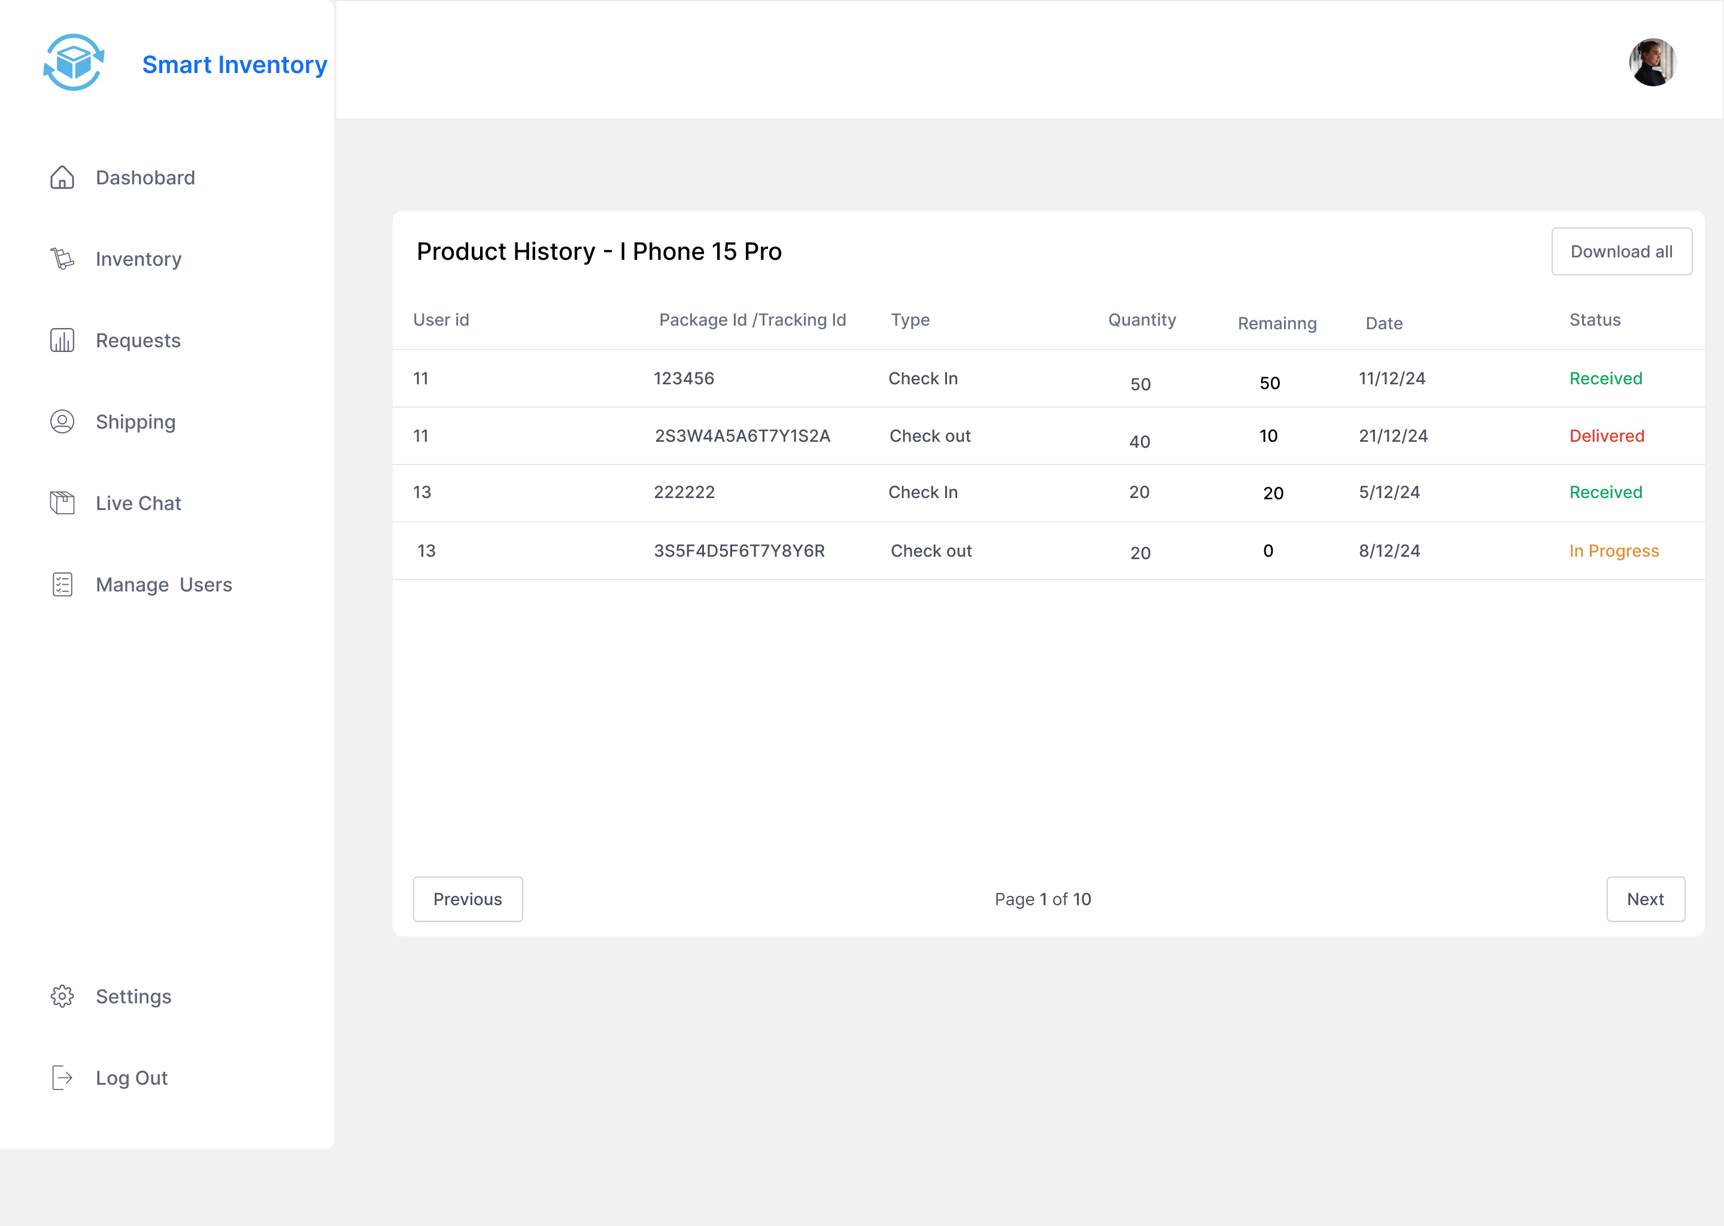

Managing Users :

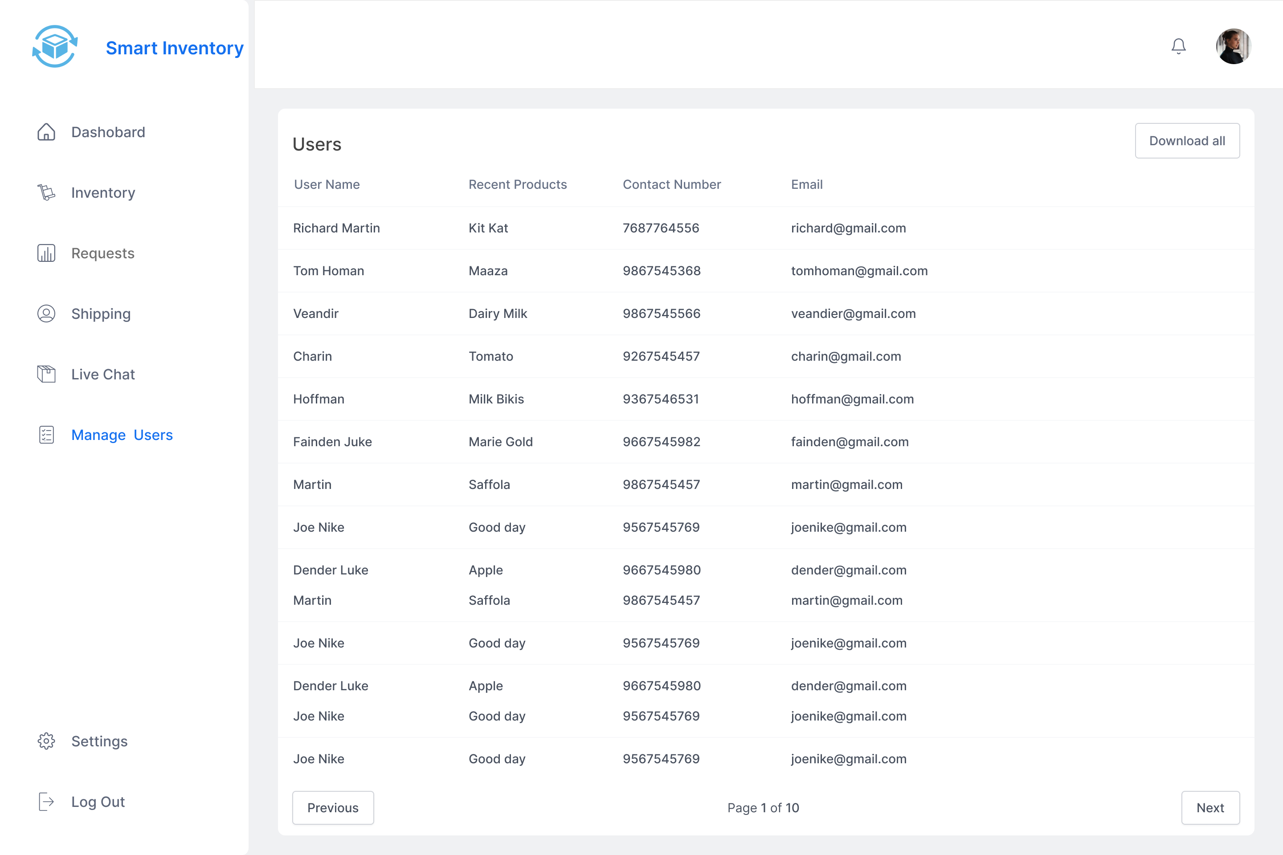

**UserInventory:**

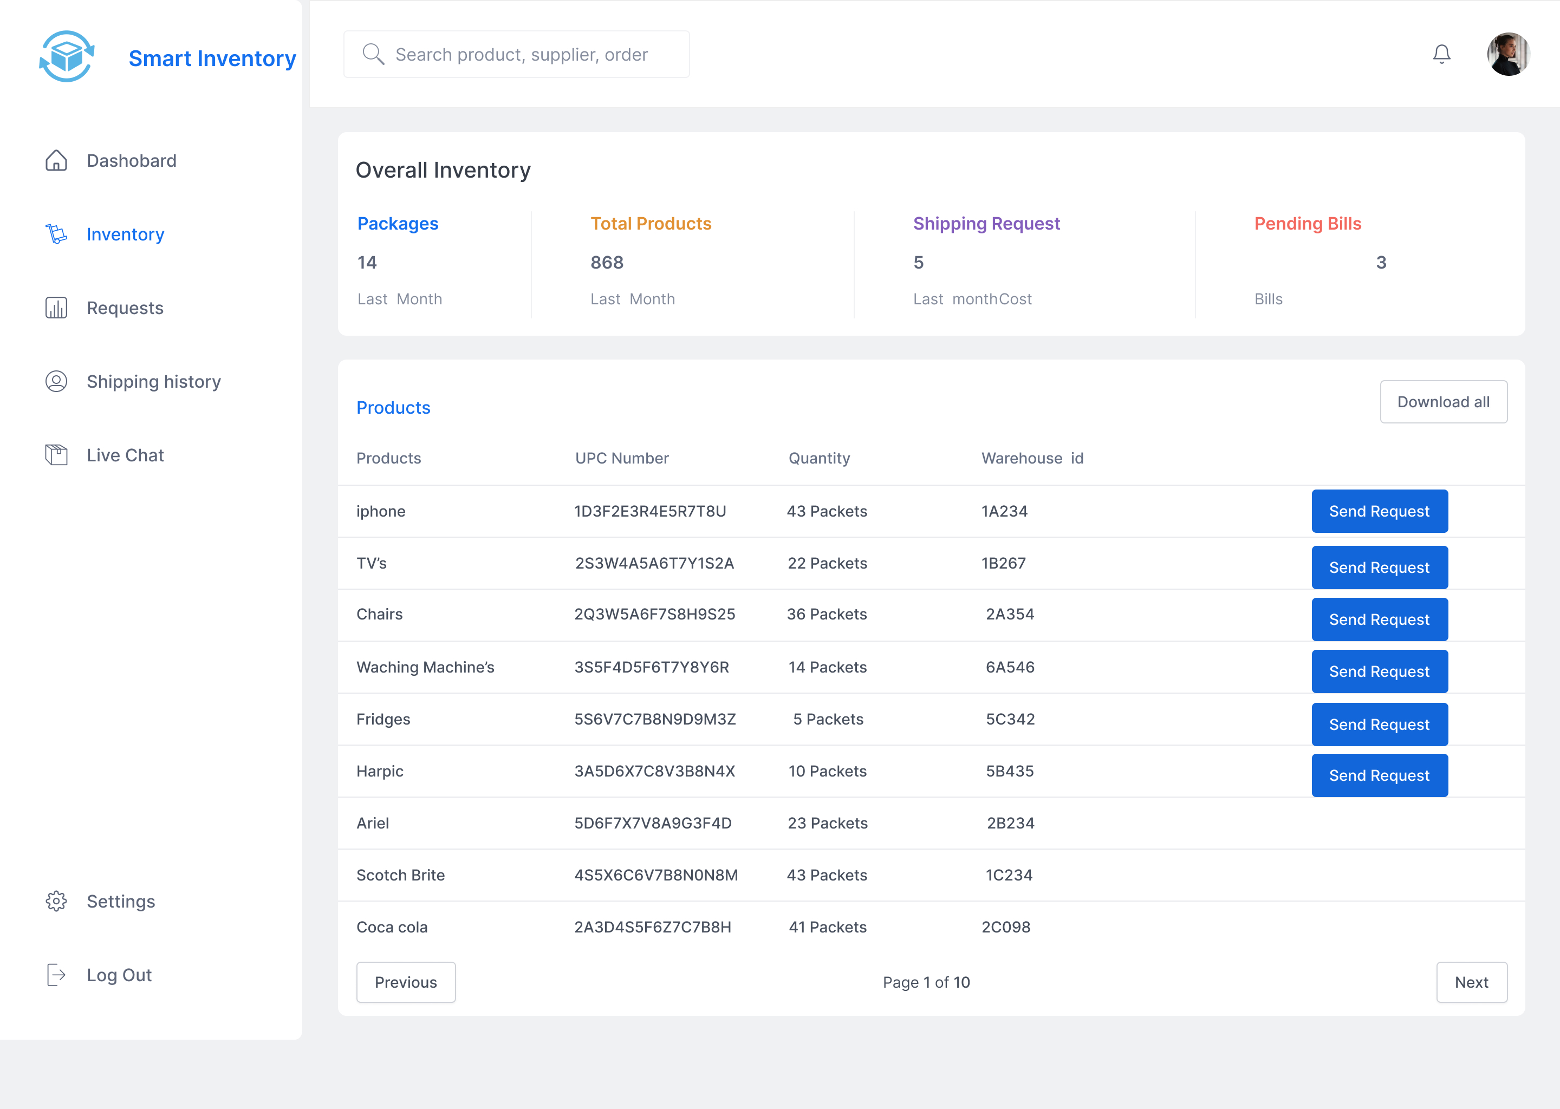

**User Requests**

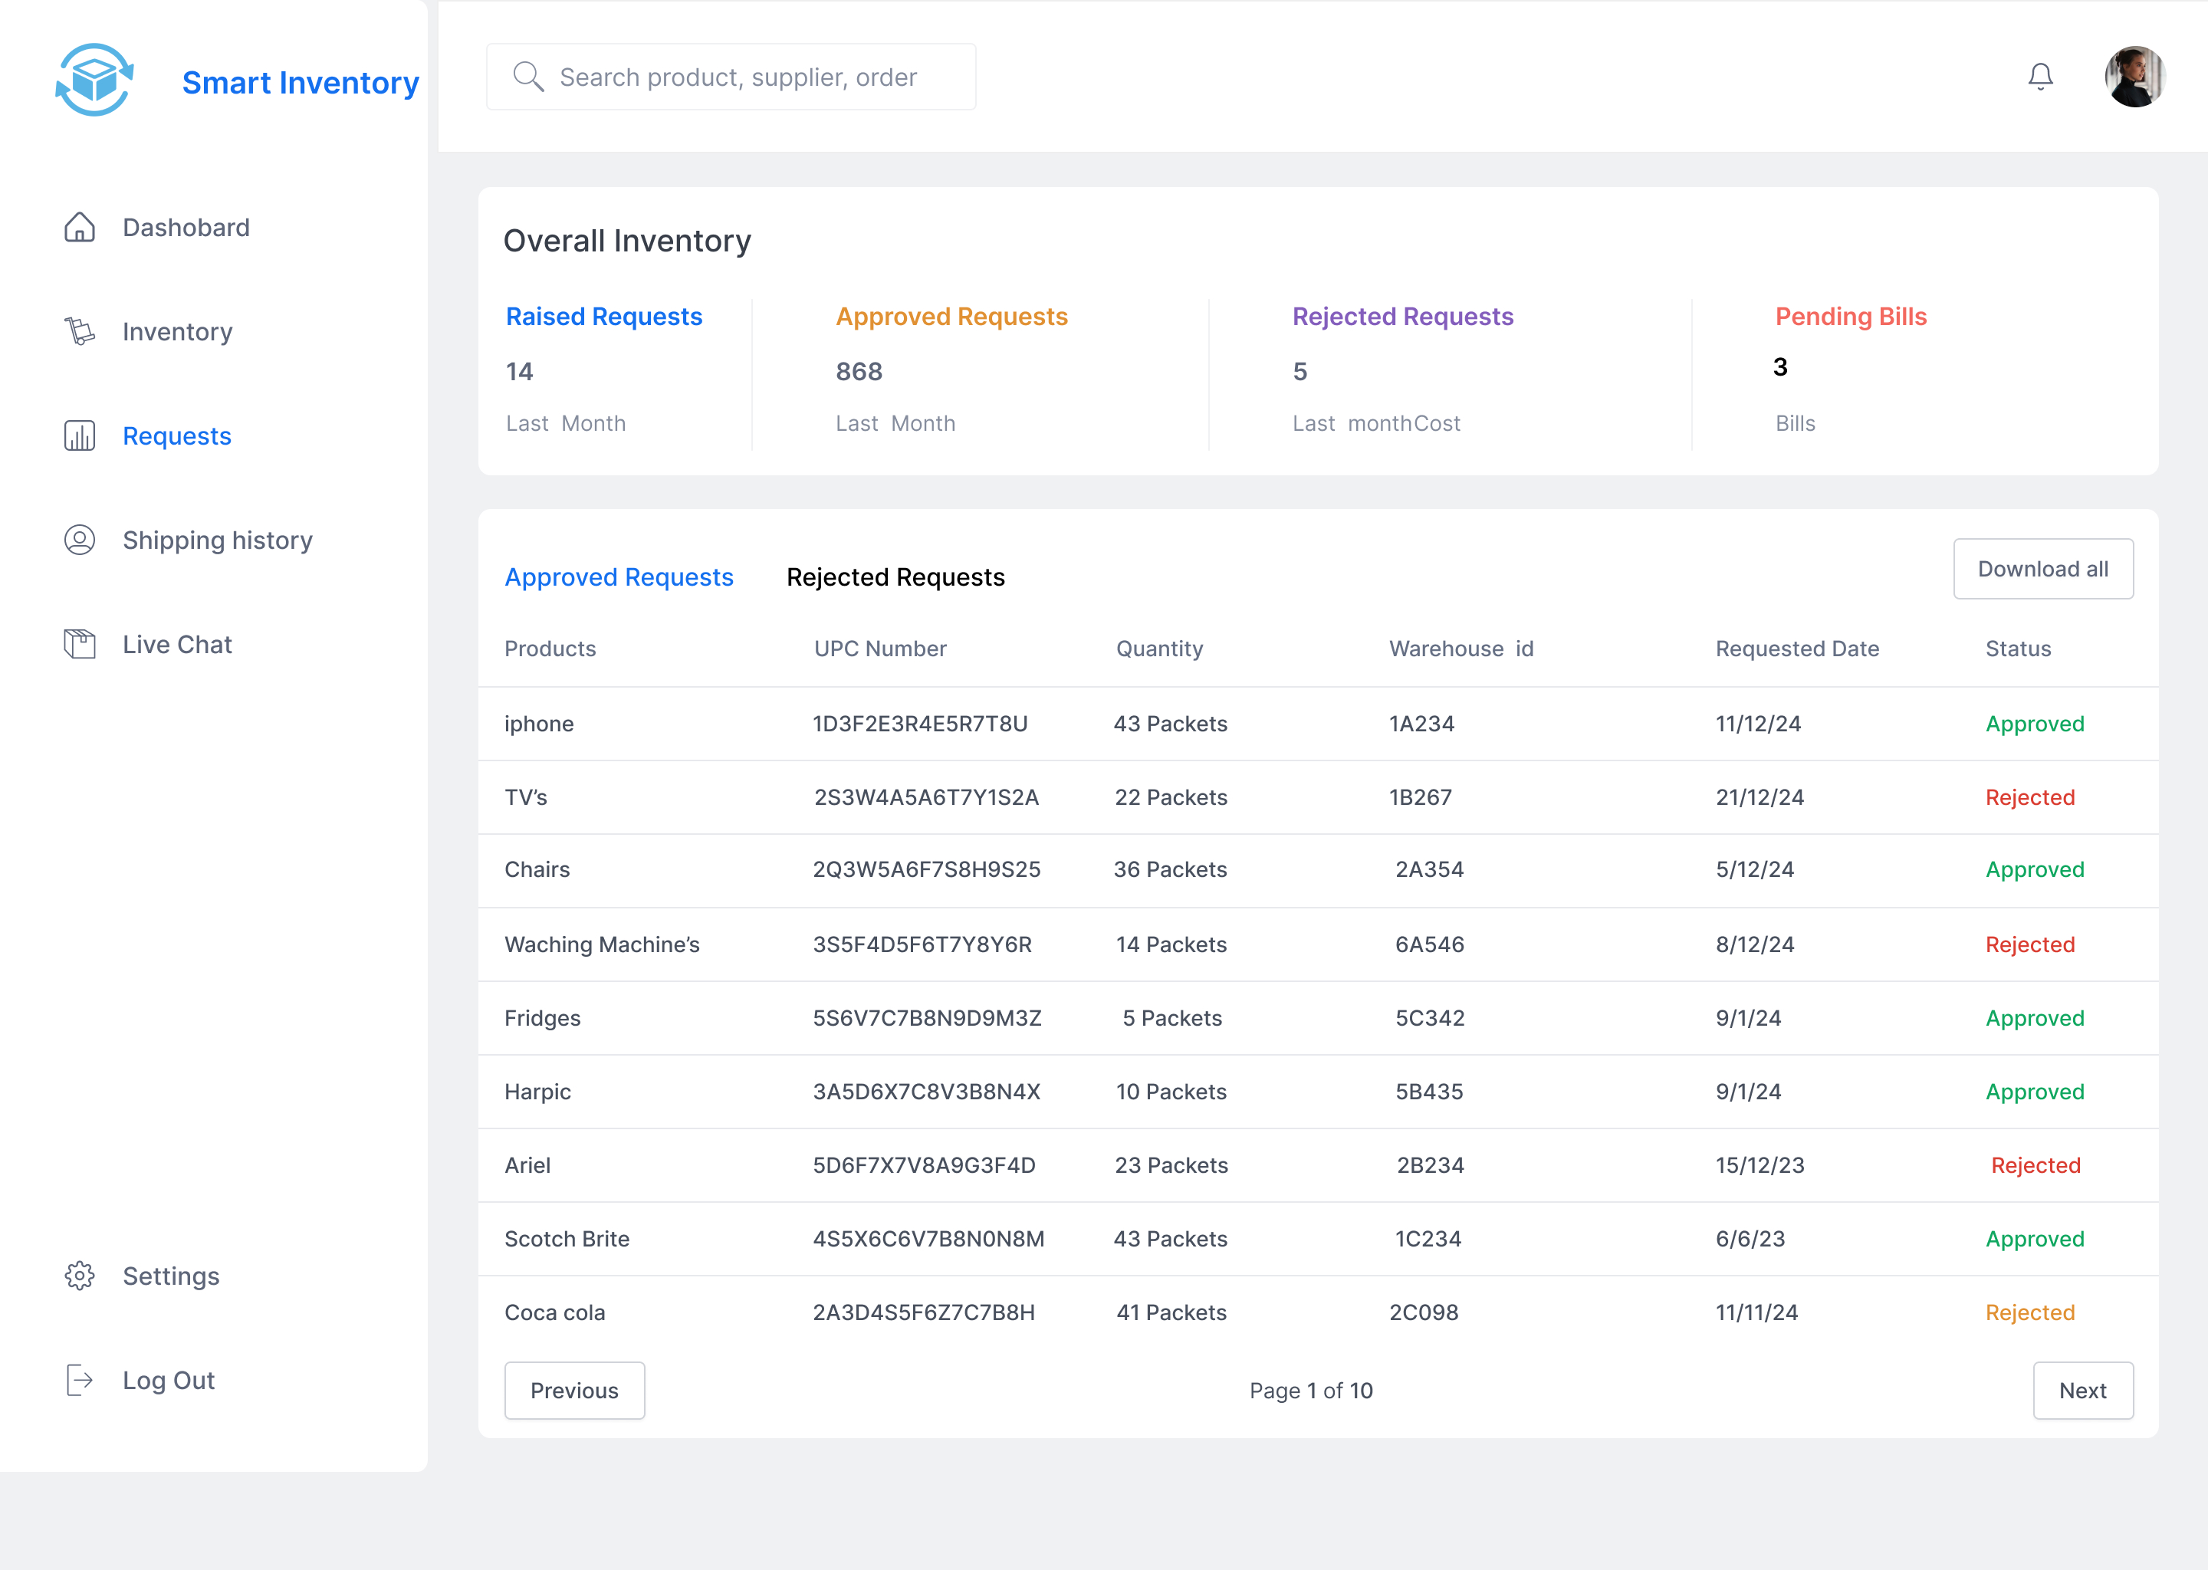

**RequestForm**

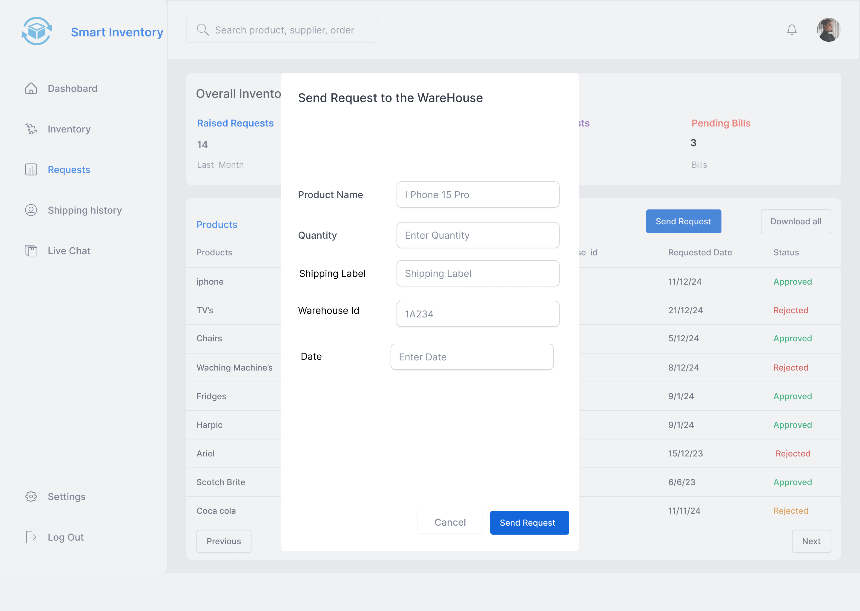

**Shipping History:**

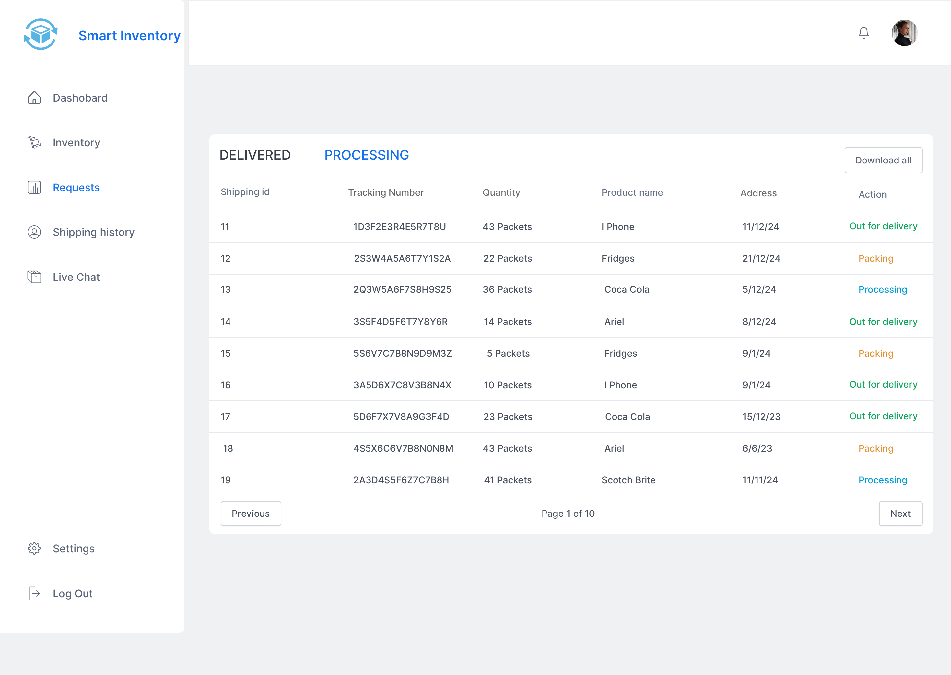

**Billing :**

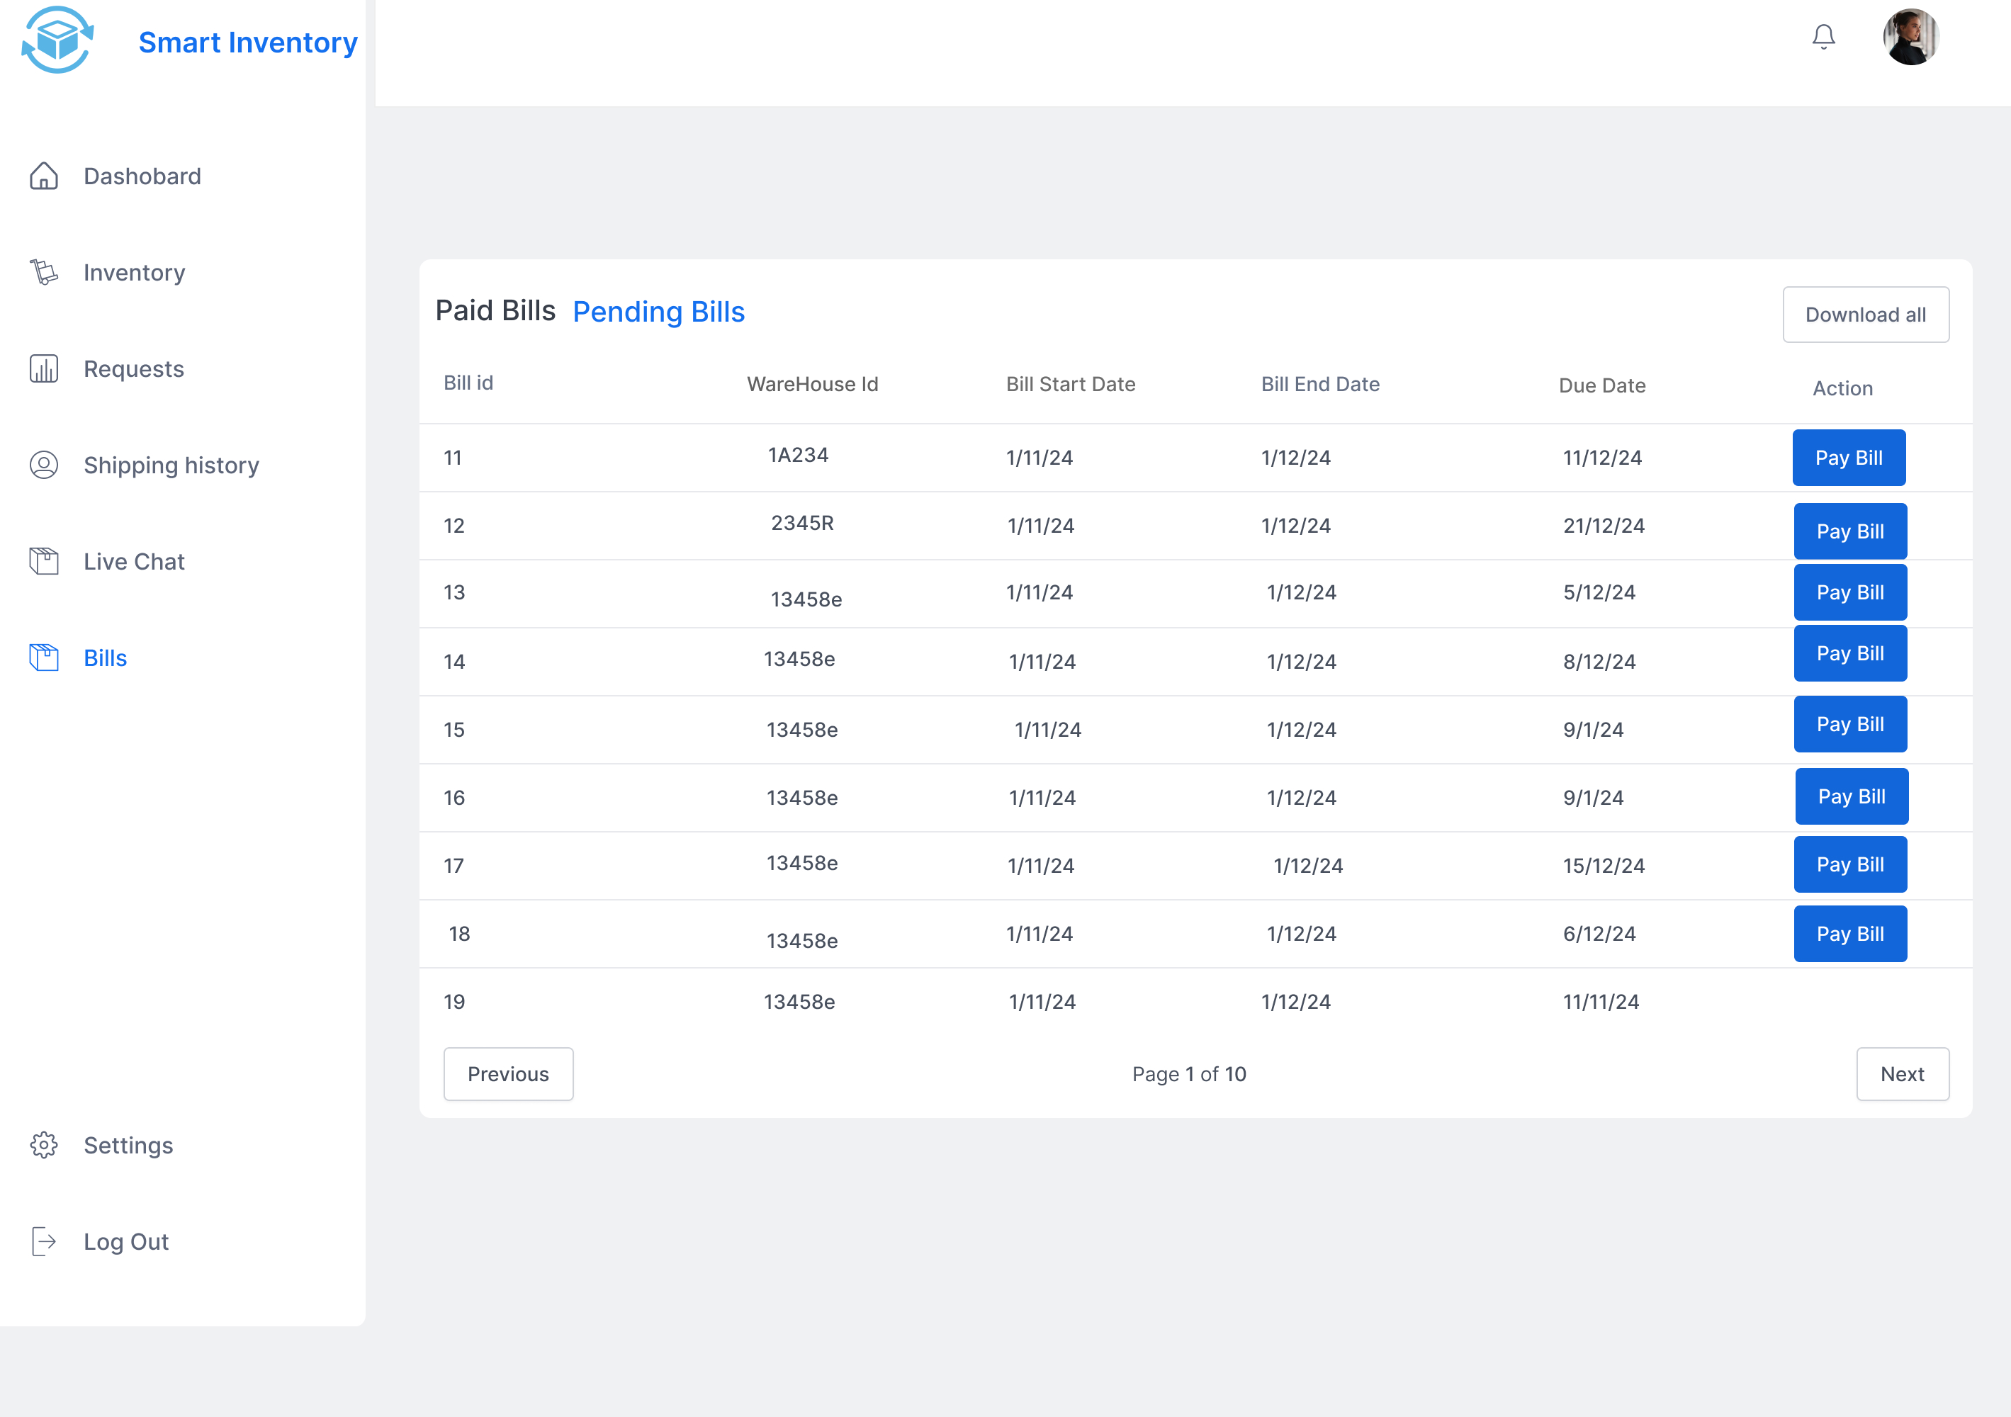

**Data flow diagram:**

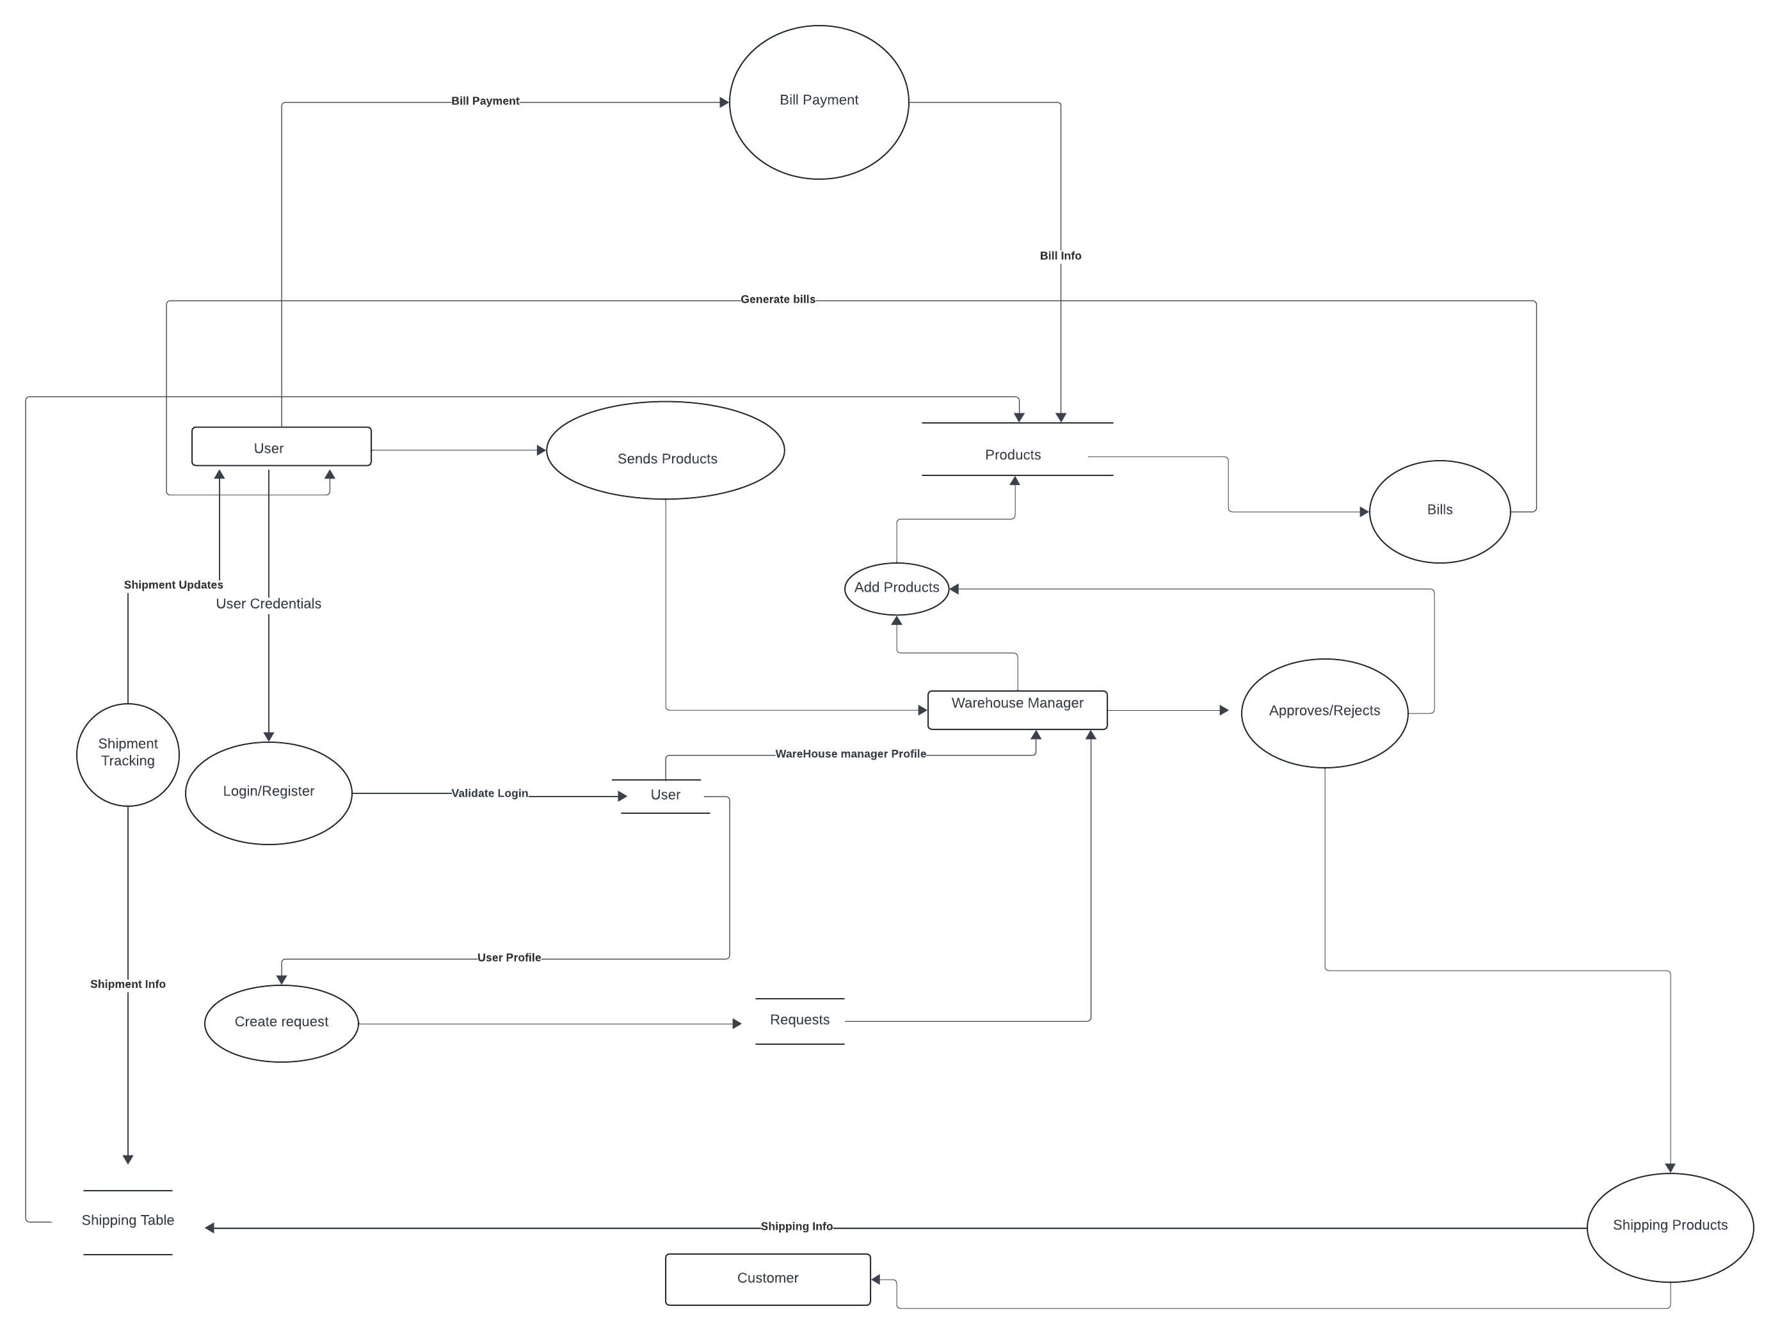

**Sequence Diagram**

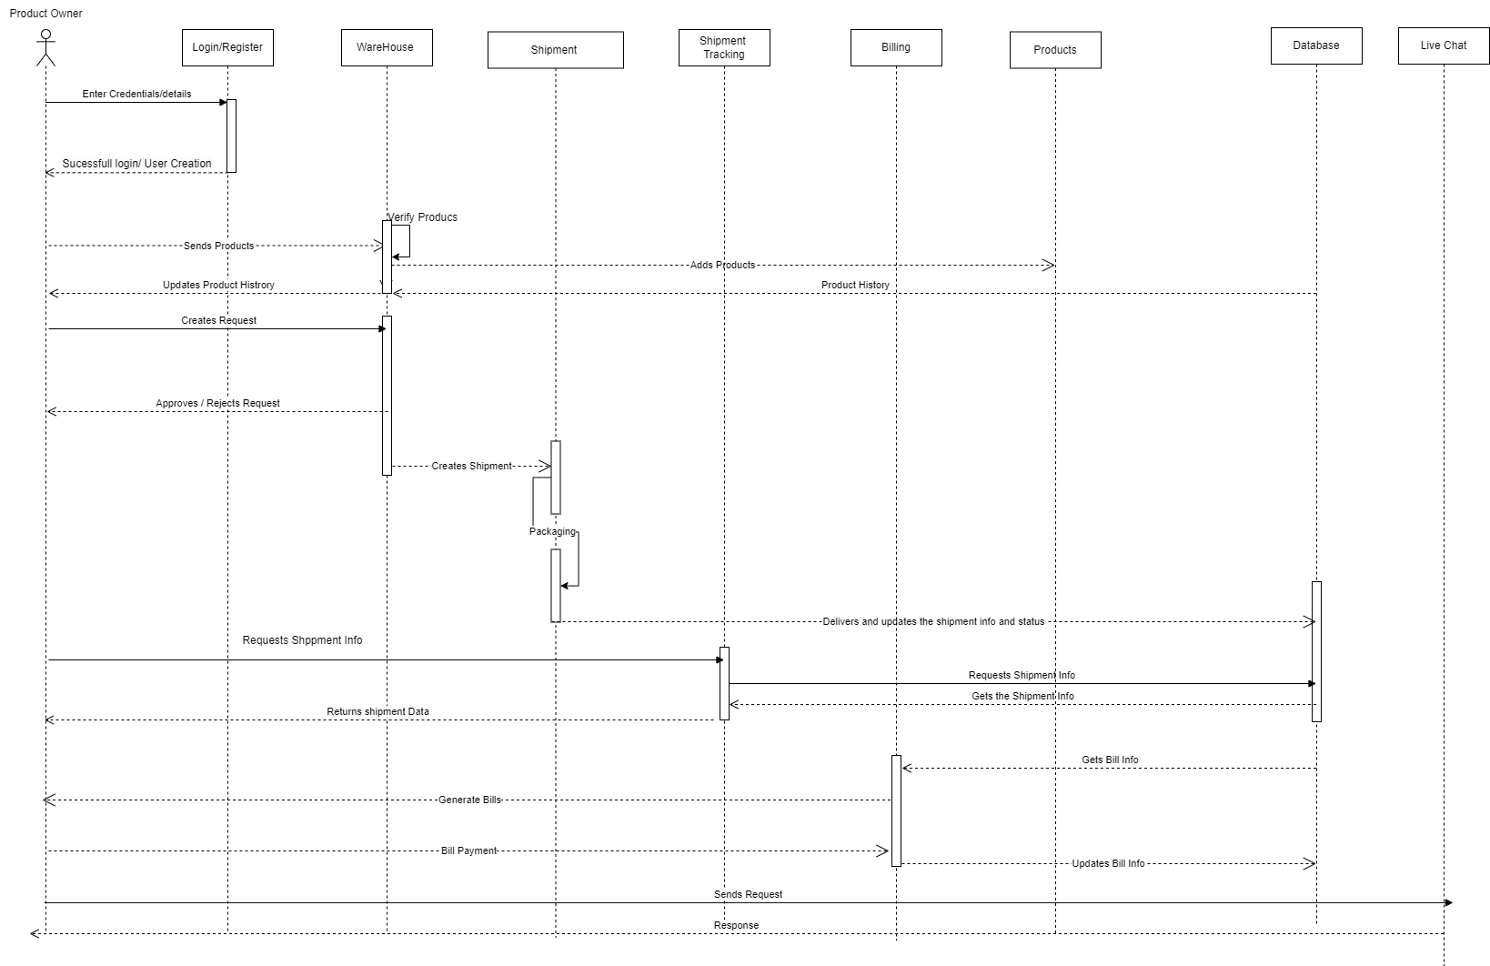

**User Manual:**

**Clone the Repository**

* Download or clone the repository to your system.
* Save it in a folder where you plan to work on the project.

**Install Required Tools**

You will need the following tools:

**a) Spring Tool Suite (STS)**

* Download Spring Tool Suite from its official website.
* After downloading, extract the zip file to a location on your system.

**b) Lombok JAR**

* Download the Lombok JAR file.
* Place the Lombok JAR inside the folder where you extracted the Spring Tool Suite.

**c) MySQL Workbench**

* Download MySQL Workbench from its official website.
* Install the application by following the installation instructions.
* Once installed, create a new instance and set a password for it.

**Configure the Spring Tool Suite**

* Open Spring Tool Suite by clicking on its executable file.
* In the tool, click on File > Import.
* Select the option Maven > Existing Maven Projects.
* Browse to the folder where you cloned the repository and select it.
* Click Finish to import the project into Spring Tool Suite.

**Configure Dependencies**

* After importing the project, Spring Tool Suite will automatically detect and download the required dependencies. Ensure this step completes before proceeding.

**Update MySQL Configuration**

* Navigate to the application.properties file located in the resources folder of the project.
* Open the file and update the MySQL configuration with the password you set during the MySQL Workbench setup.

**Run the Application**

* Once all dependencies are installed, you can run the application from Spring Tool Suite.
* Right-click the project.
* Select Run As > Spring Boot App.
* The application will be available locally on port 8080. Open a browser and navigate

**Technical Manual:**

**User Management Module:**

**Login Page:**

* Enter your username and password, then click Login to access your account.
* Forgot password? Click Reset password to create a new one.
* Don’t have an account? Click Sign up to create one.

**Sign Up Page:**

* Enter your username, email, password, and confirm the password.
* Click Create account to register.
* Already registered? Click Log in to return to the login page.

**Reset or Forgot Password Page:**

* Enter your registered email and click Submit to get a reset password link in your email.
* Open the link, confirm your username, and email, and create a new password.
* Click Change password to update it.
* Click Login to sign in or sign up to create a new account.

**Authorization (to register warehouse manager):**

* First, create an account as a normal user.
* Then, update the user's role to Admin in the database.
* Add the Warehouse ID for that manager in the database.

**Chat Functionality:**

**Online Users List:**

* + On the left, you can see a list of users currently online.
  + This list updates dynamically as users join or leave the chat.
  + Based on the messages received time, the users will be sorted.

**Chat Messages Section:**

* + The middle area displays all the messages exchanged in the chat.
  + Messages will appear in real-time for a seamless conversation experience.

**Message Input Box:**

* + Type your message in the input box at the bottom.
  + Click the Send button to share your message with others.

**Product List Display:**

* The page displays a table of products with details such as image, name, UPC number, package ID, tracking ID, quantity, warehouse ID, arrival date, and availability.

**Create Order Modal:**

* Each product has a "Create Order" button. Clicking it opens a modal form pre-filled with the selected product's details (name, warehouse ID, etc.).

**Order Quantity Input:**

* The modal allows users to specify the quantity they want to order, with a maximum limit set based on the product's available quantity.

**Shipping Label Upload:**

The modal includes a file input field to upload a shipping label (PDF file) for the order.

* Hidden Inputs for Product ID:
* The modal contains hidden inputs for the product ID, which is used to identify the product when the order is created.

**Data Table for Sorting and Searching:**

* The products table uses the Data Tables jQuery plugin, which enables features like sorting, searching, and pagination.

**Form Submission:**

* When the order is placed, the form sends the order data to the server for processing (via POST request to /create-order).

**Success/Failure Notification:**

* After the form submission, a SweetAlert notification is triggered, displaying a success or failure message based on the server’s response.

**Conditional Message Display:**

* Hidden inputs store the order status (order Placed) and a corresponding message. If an order is successfully placed, a success message appears; otherwise, a failure message is shown.

**Functionalities of the Order History and Tracking Page**

**Search Orders**

User filter the order list using specific criteria:

**Tracking ID Search**:

* Input a tracking ID to locate a specific order.
* The entered value is pre-populated on the page if the search is repeated, ensuring a smooth user experience.

**Filter by Status:**

* Select an order status (e.g., Processing, Packing, etc.) from the dropdown to filter orders by their current status.
* The selected option is retained in the dropdown during subsequent searches.

**Search Execution:**

* The form sends a GET request to the /admin/get-orders endpoint with the tid (Tracking ID) and status parameters.

**Display Orders List**

All orders matching the search criteria are displayed with detailed information:

**Order Details:**

* **Order Number:** Displays the sequence number of the order.
* **Order Status**: Shows the current status (e.g., Delivered, Processing).
* **Client Name**: Displays the name of the client who placed the order.
* **Tracking Number**: Displays the unique tracking number of the order.

**Product Details:**

* **Product Name**: Displays the name of the ordered product.
* **Quantity**: Shows the quantity of the product ordered.
* **Order History Link**: A link to view the detailed history of the order.

**Update Order Status**

Admins can update the status of an order directly from the order list:

**Status Dropdown**:

* Displays the current status of the order with options to change it.
* Possible statuses include Processing, Packing, Out for Delivery, Delivered, and Rejected.

**Form Submission**:

* The form sends a POST request to /admin-update-order-status with:
* **orderStatus**: The new status selected by the admin.
* **orderId**: The unique ID of the order.

**Confirmation Button**:

Clicking the Change Status button updates the order's status.

**Functionalities of the Billing Page**

**Current Billing Cycle**: Shows bills for the current month, including billing period, due date, amount due, and payment status. Users can pay pending bills via a Pay Now button, which opens a payment modal for card details.

**Billing History**: Lists past bills in card format, showing billing period, amount paid, payment date, due date, and status (Paid/Unpaid).

**Payment Modal**: Allows users to enter card details to pay for unpaid bills. Payments are processed, and the page updates the status dynamically.

**Dynamic Rendering with Thymeleaf**: Uses Thymeleaf to display real-time data and handle conditions like no bills or displaying payment status.